DESIGN PROCESS – O365-SharePoint

Countries list

# As A – I Want – So That

1. **AS A**: End user – **I WANT**: A countries listing – **SO THAT:** I can use it in my information architecture requirements and demo a quick use of SharePoint List, Column-formatters and usage of Flow to migrate/populate data from external sources.

# Solution Approach

Create a SharePoint list of choice to store Country, Country Code etc. Then, create a Flow to use external and free Http Get URL/Resources to populate data, including Flag information etc. Use JSON-column-formatter to enhance the look and feel of the List.

# Solution Design

## Information Architecture

Content Type: **Countries**

|  |  |  |
| --- | --- | --- |
| **Title** | **Single line** | **Default item property** |
| **CountryCode2** | **Single line** | **2-character length country code** |
| **CountryCode3** | **Single line** | **3-character length country code** |
| **CountryCallingCodes** | **Single line** | **-** |
| **FlagUrl** | **Single line** | **-** |
| **Latitude** | **Single line** | **-** |
| **Longitude** | **Single line** |  |
| **RESTCountriesEUJSON** | **Multi line text** | **Full JSON object serialized as string** |
| **WikiUrl** | **CALCULATED Column - Single line** | **="https://en.wikipedia.org/wiki/"&[Title]** |
|  | | |

## MS-Flow

**https://restcountries.eu/**

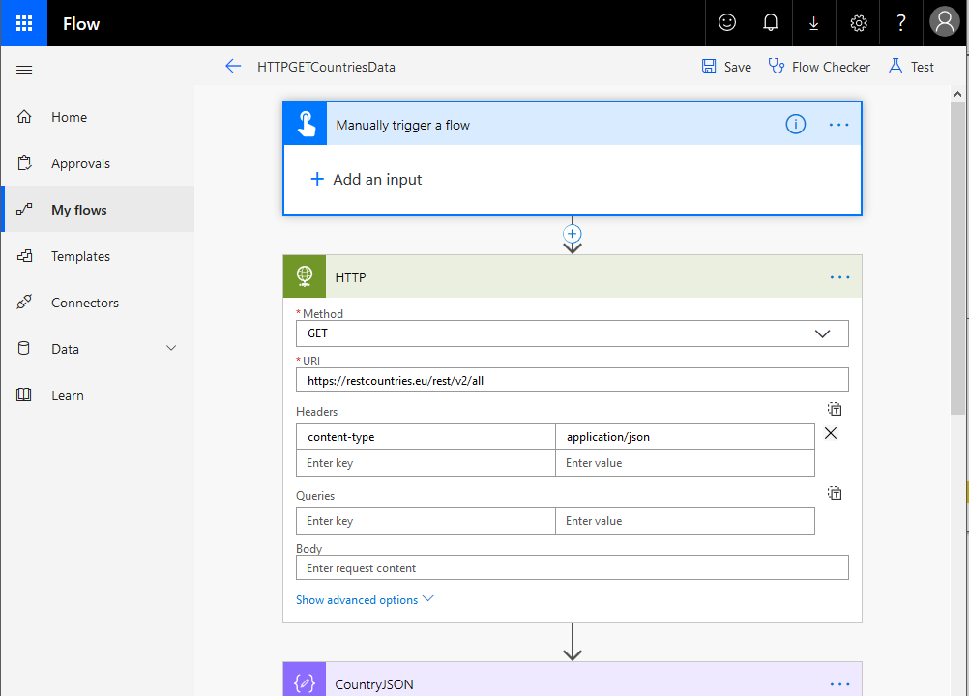

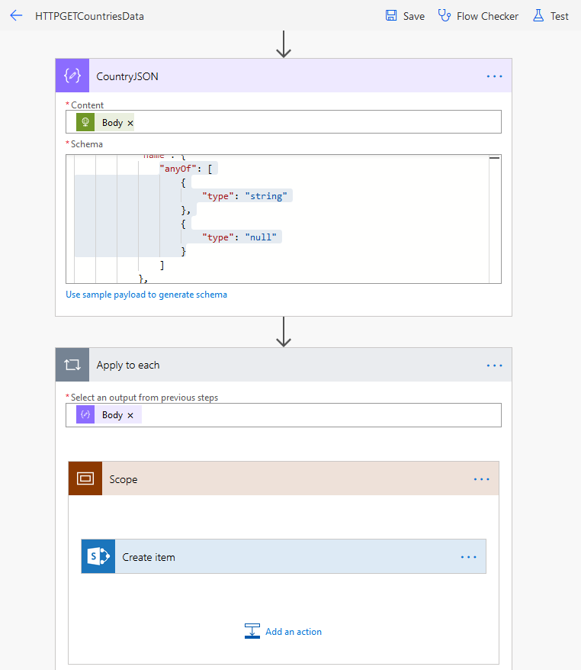

Sometimes, JSON schema has to be patched – for return-types not being deducted exactly from interpretation of sample data and also, for null properties/values/types in the returned data. Example:

"name": {

**"anyOf": [{"type": "string"}, {"type": "null"}]**

}

"population": {

**"anyOf": [{"type": "integer"}, {"type": "number"}, {"type": "null"}]**

}

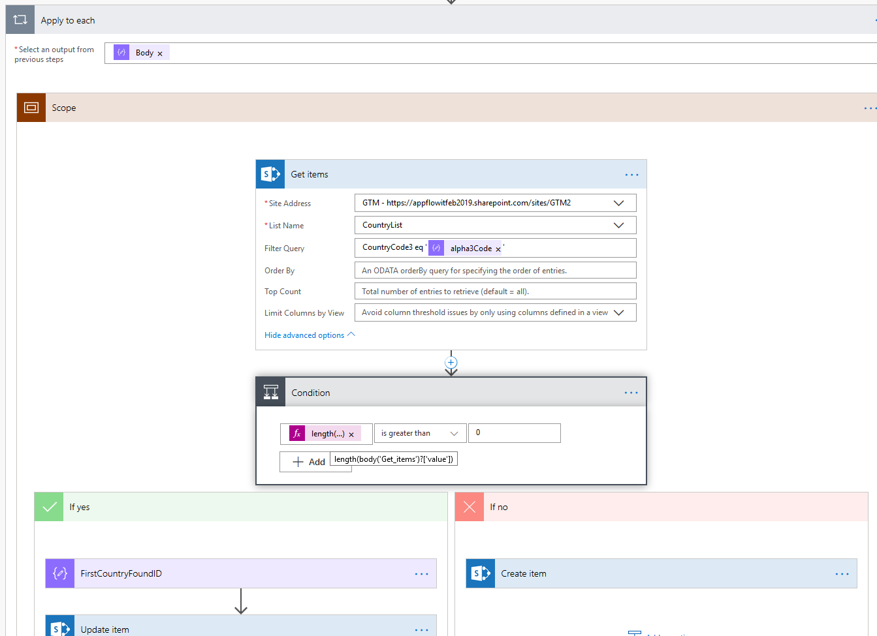

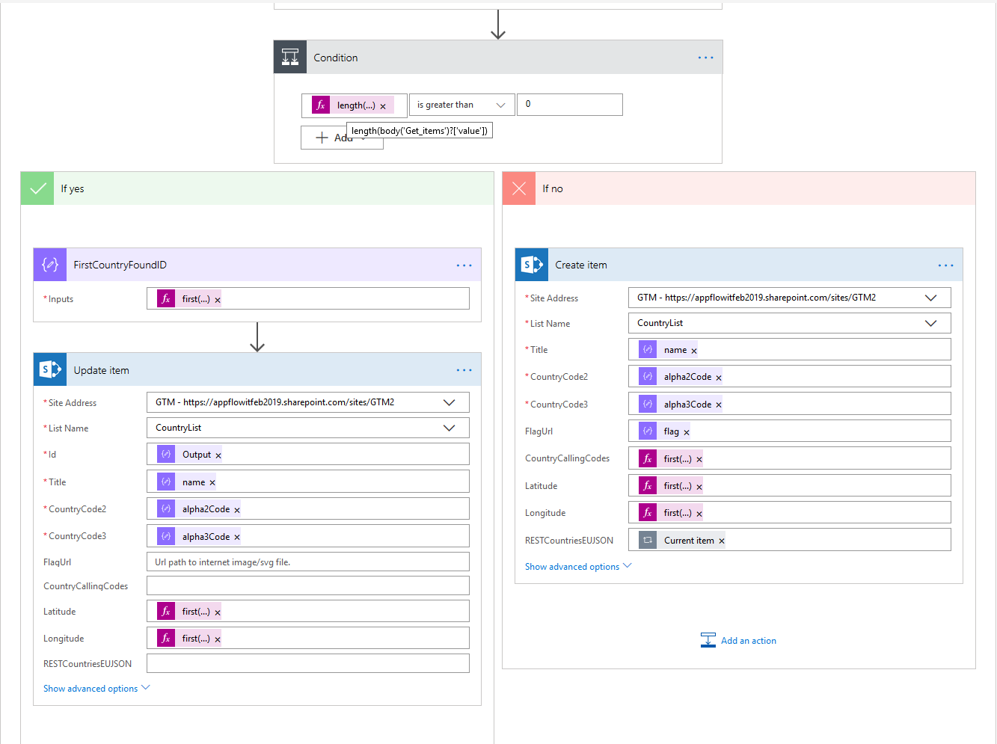

**first(item**s**(**'Apply_to_each'**)**['callingCodes']**)**

**first(item**s**(**'Apply_to_each'**)**['latlng']**)**

**first(skip(items('Apply_to_each')['latlng'],1))**

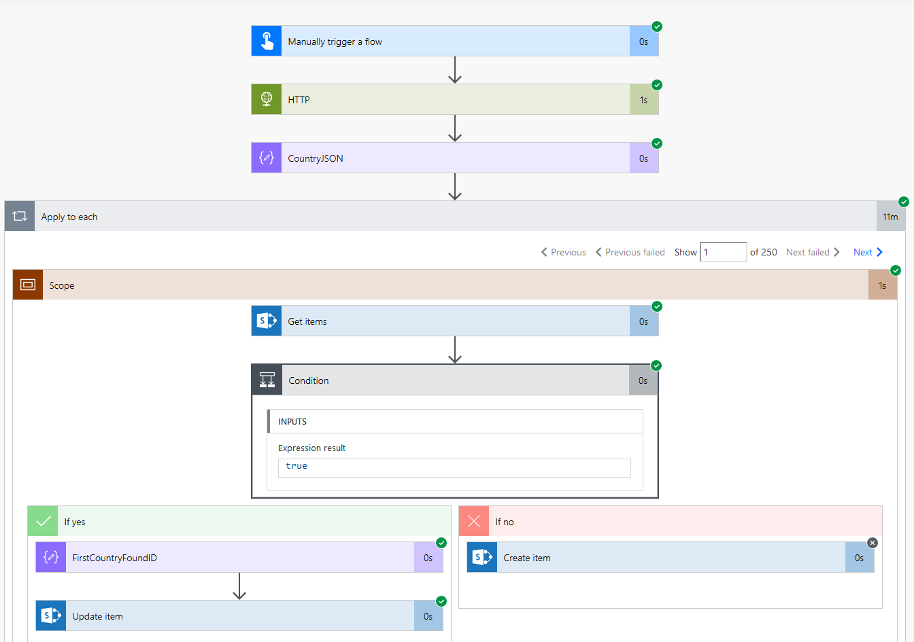

## SharePoint List

SharePoint List – Default view with Column formatter on the FlagUrl field (“Format this column”)

***SharePoint List Column/Row: Formatter Reference:***

|  |  |
| --- | --- |
| Column | <https://docs.microsoft.com/en-us/sharepoint/dev/declarative-customization/column-formatting> |
| Row/View | <https://docs.microsoft.com/en-us/sharepoint/dev/declarative-customization/view-formatting> |
| Syntax Ref | <https://docs.microsoft.com/en-gb/sharepoint/dev/declarative-customization/column-formatting#detailed-syntax-reference> |
| Pluralsight | <https://app.pluralsight.com/player?course=sharepoint-framework-extensions&author=sahil-malik&name=4b77fe11-5ab7-4161-9331-819099c4cbb7&clip=2&mode=live> |

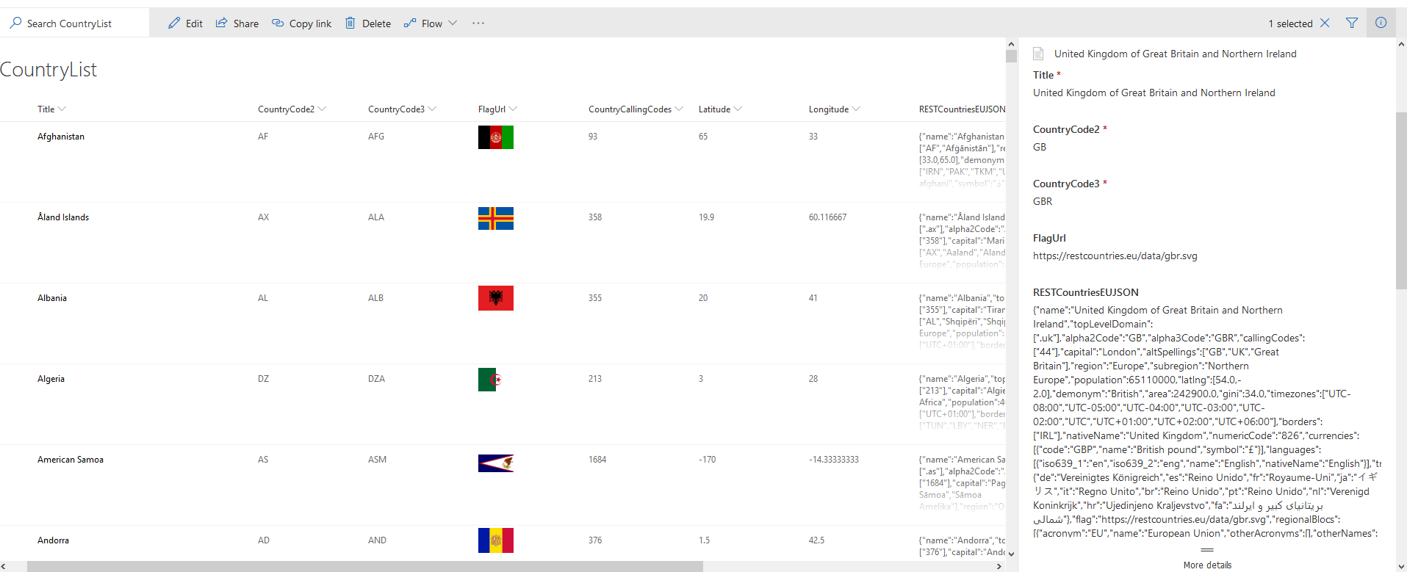

### JSON - Column Formatter

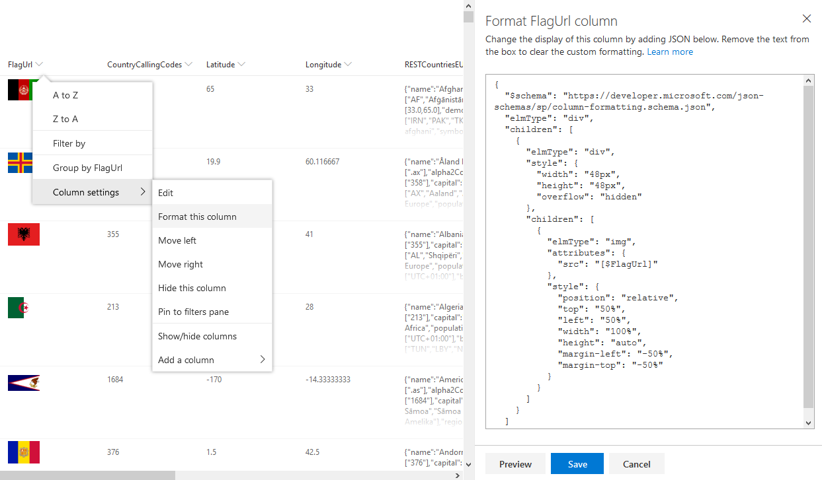

{

"$schema": "https://developer.microsoft.com/json-schemas/sp/column-formatting.schema.json",

**"elmType": "div",**

"children": [

{

"elmType": **"div"**,

"style": {"width": "48px","height": "48px", "overflow": "hidden"},

"children": [

{

"elmType": **"img"**,

"attributes": {"src": "**[$FlagUrl]**"},

"style": {

"position": "relative",

"top": "50%", "left": "50%",

"width": "100%","height": "auto",

"margin-left": "-50%","margin-top": "-50%"}

}

]

}

]

}

### JSON - Row/View Formatter

**{**

"$schema": "https://developer.microsoft.com/json-schemas/sp/view-formatting.schema.json",

"hideColumnHeader": true, "hideSelection": true,

"**rowFormatter**": {

"elmType": "button",

"customRowAction": {"action": "defaultClick"},

"attributes": {"class": "ms-bgColor-white"},

"style": {"margin": "10px", "padding": "0 5px 0 0","border-width": "3px","border-radius": "20px", "border-style": "none", "cursor": "pointer"},

"children": [{

"elmType": "img",

"attributes": {

**"src":"='https://dev.virtualearth.net/REST/v1/Imagery/Map/AerialWithLabels/'+ [$Title] + '?mapSize=300,300&key={BingMapDeveloperKeyGoesHere}'"** },

"style":{"height": "300px", "width": "300px", "margin": "10px", "padding": "0 5px 0 0" }

},

{

"elmType": "img",

"attributes": {"src": **"[$FlagUrl]"**},

"style": {"height": "128px", "width": "128px", "margin": "10px","padding": "0 5px 0 0"}

},

{

"elmType": "div",

"style": {"text-align": "right"},

"children": [{

"elmType": "div",

"txtContent": "=[$CountryCode3] +' | ' + [$CountryCallingCodes]",

"attributes": {"class": "ms-fontSize-m ms-fontWeight-regular"}

},

{

"elmType": "div",

"txtContent": "[$Title]",

"attributes": {"class":"ms-fontSize-xl ms-fontWeight-semibold"}

}

]

}

]

}

**}**

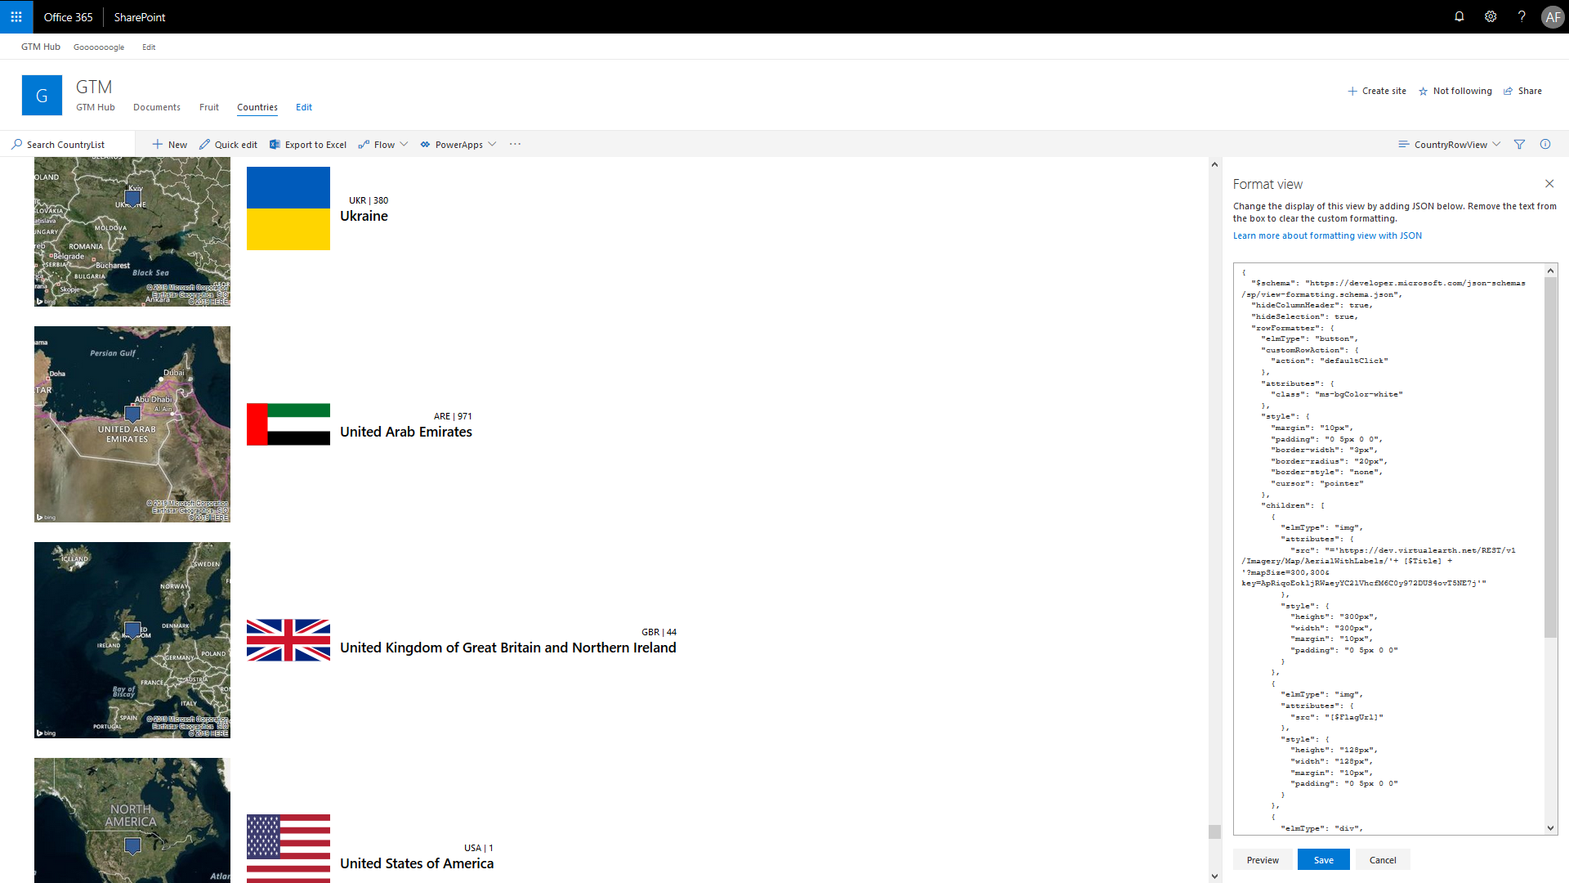

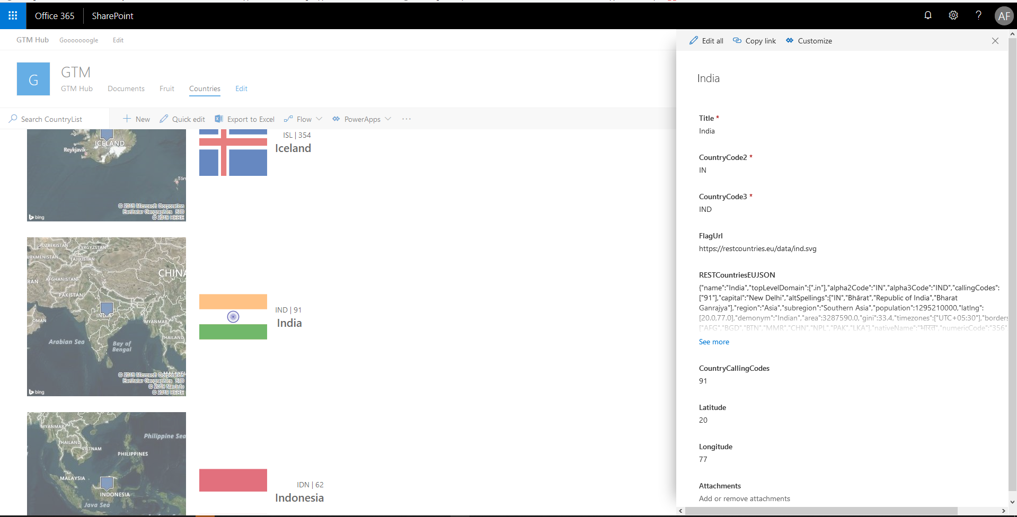

## Power BI

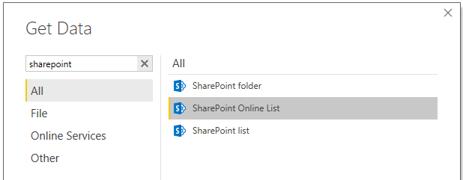

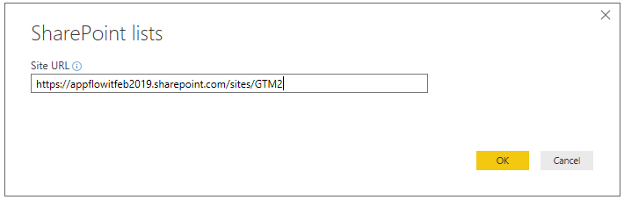

SIGN-IN and then,

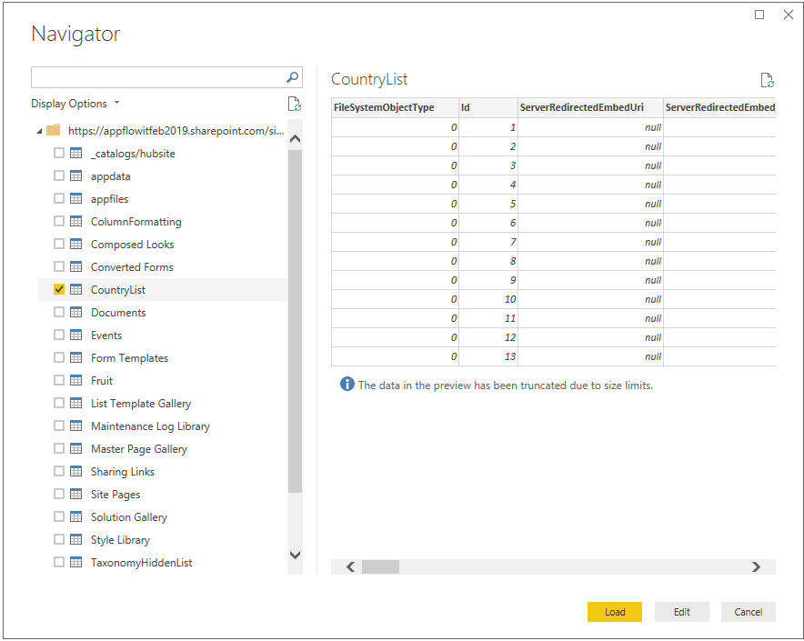

***Applying POWER-QUERY (E.T.L.):***

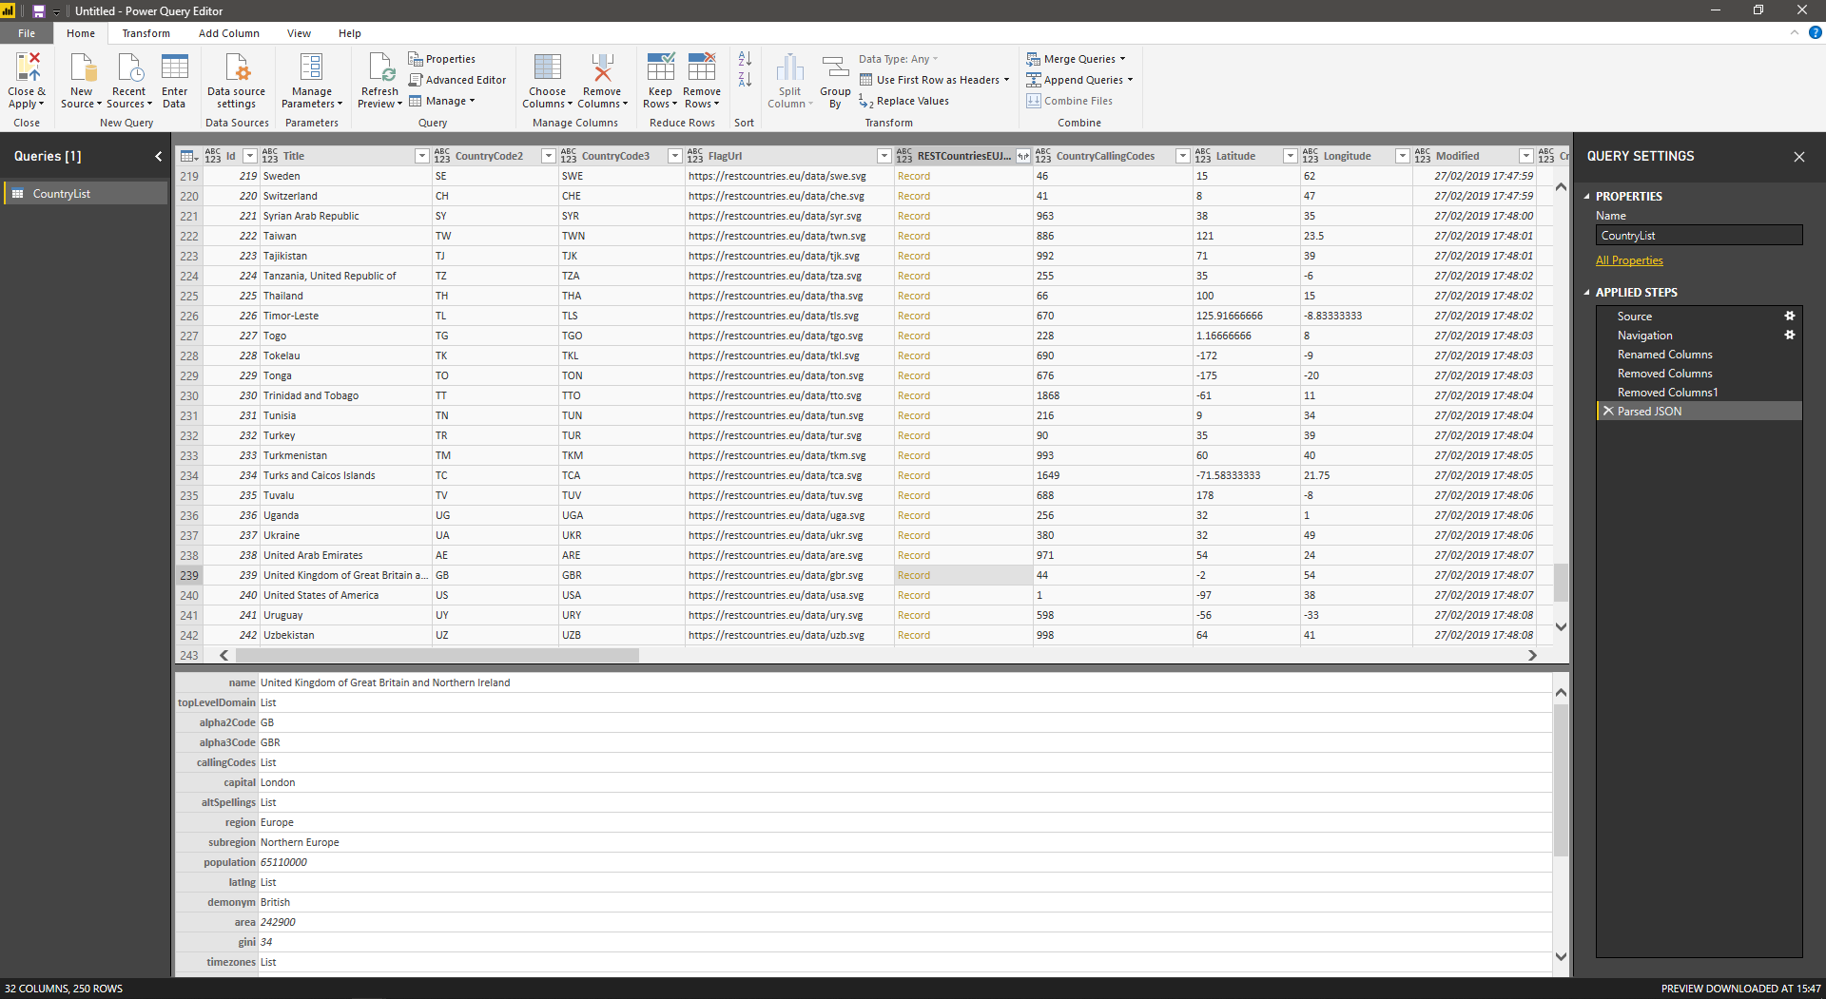

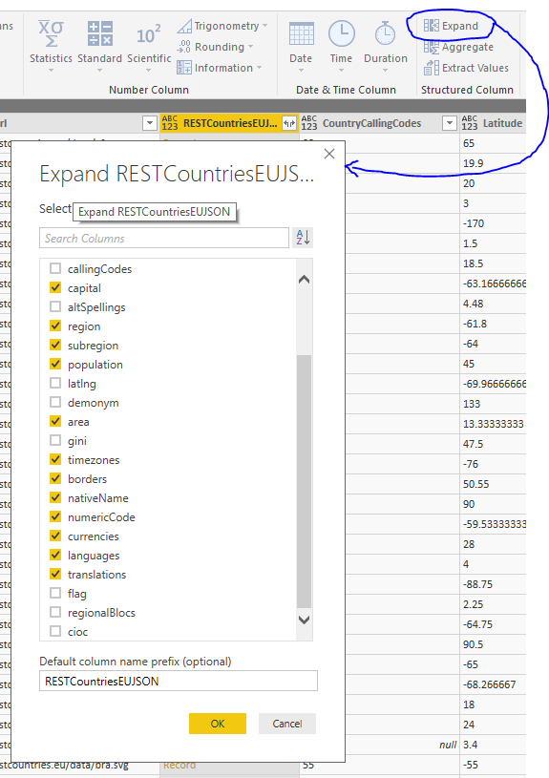 

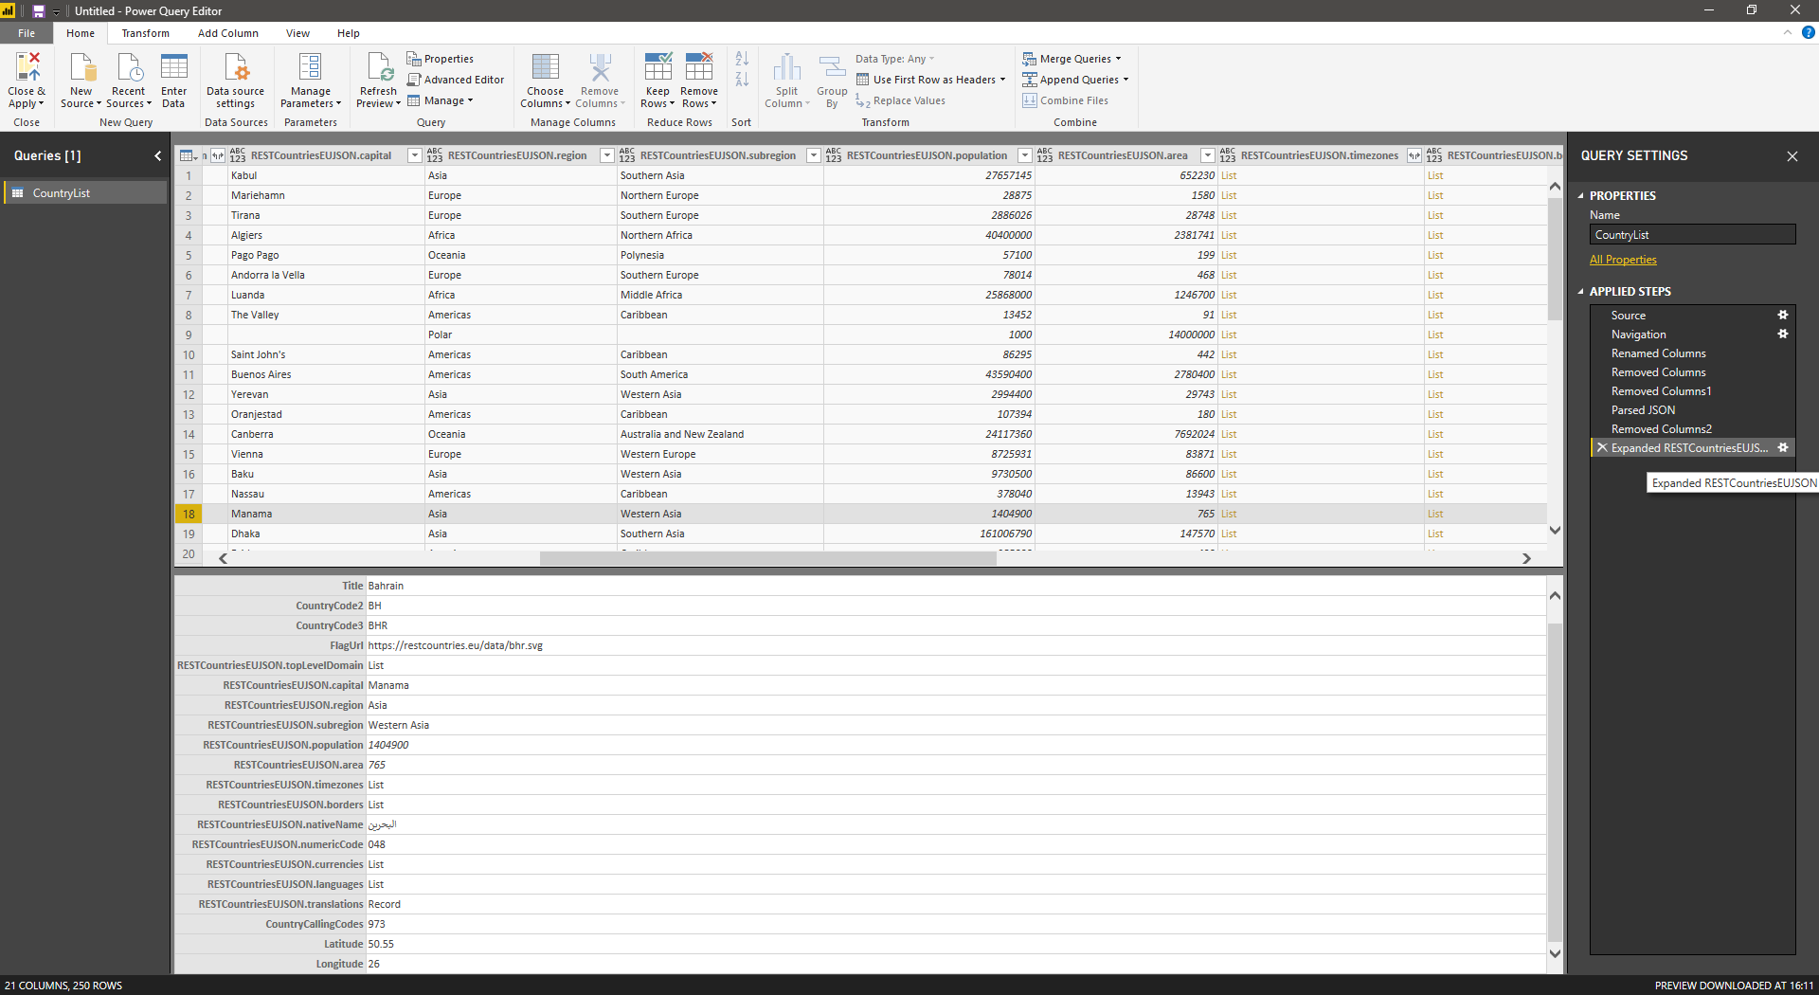

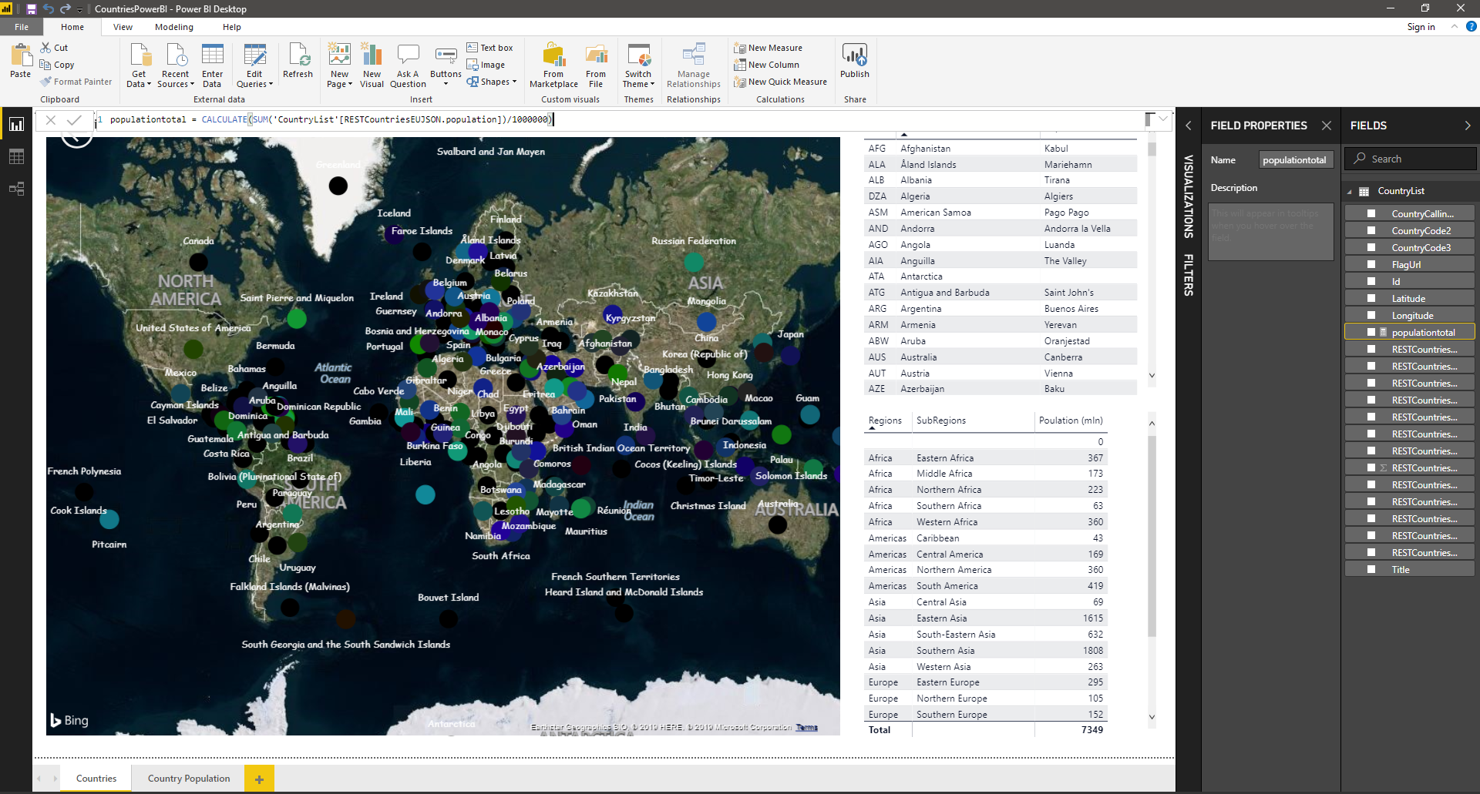

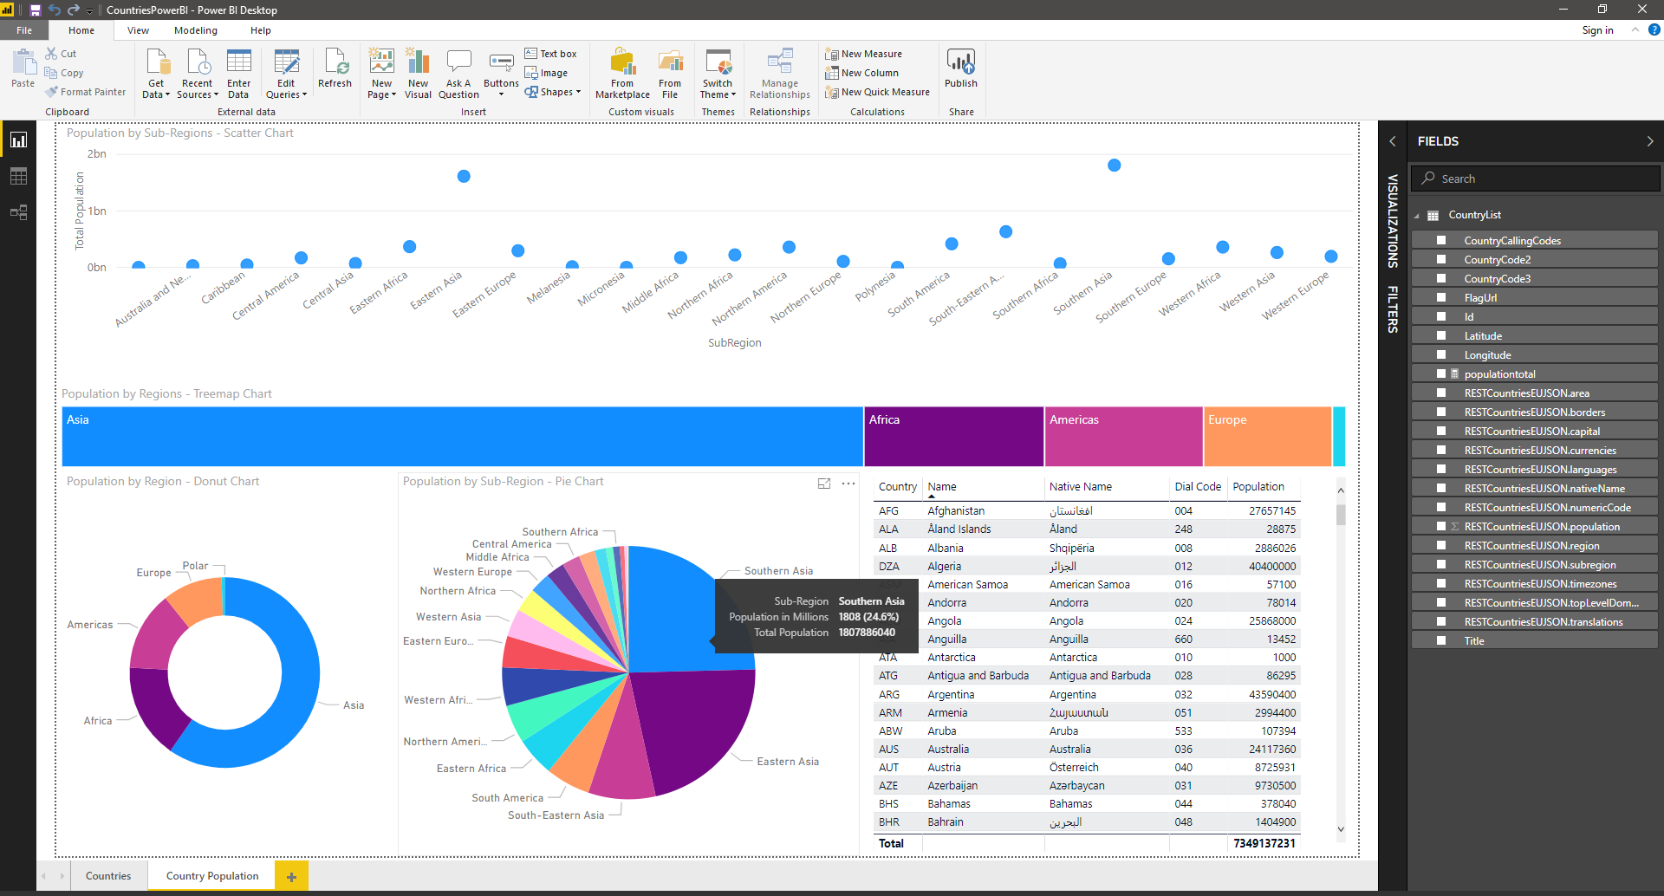

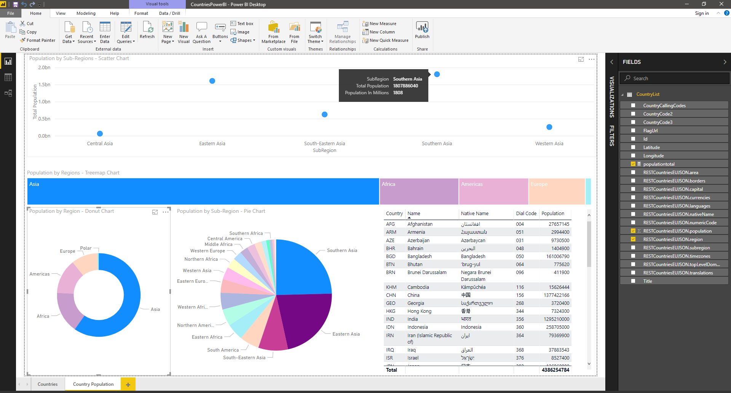

## PowerApps

Ref: <https://docs.microsoft.com/en-us/powerapps/maker/canvas-apps/reference-properties>

Ref: <https://docs.microsoft.com/en-us/powerapps/maker/canvas-apps/formula-reference>



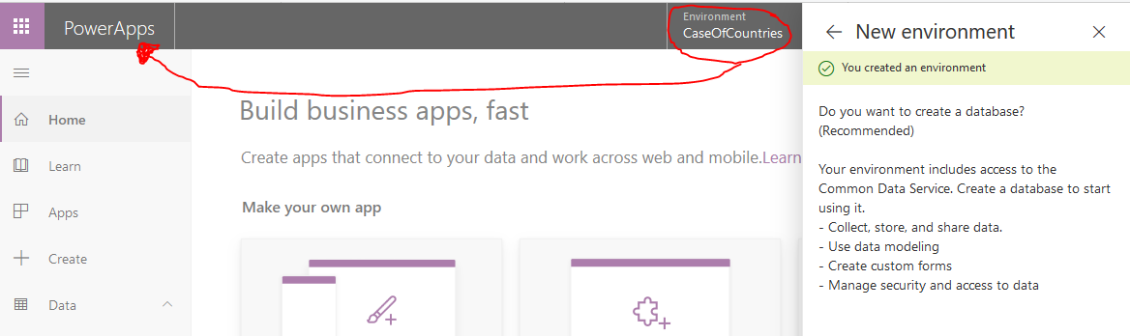

Bringing in the Flow created earlier in default environment to the new CaseOfCountries environment (solution)

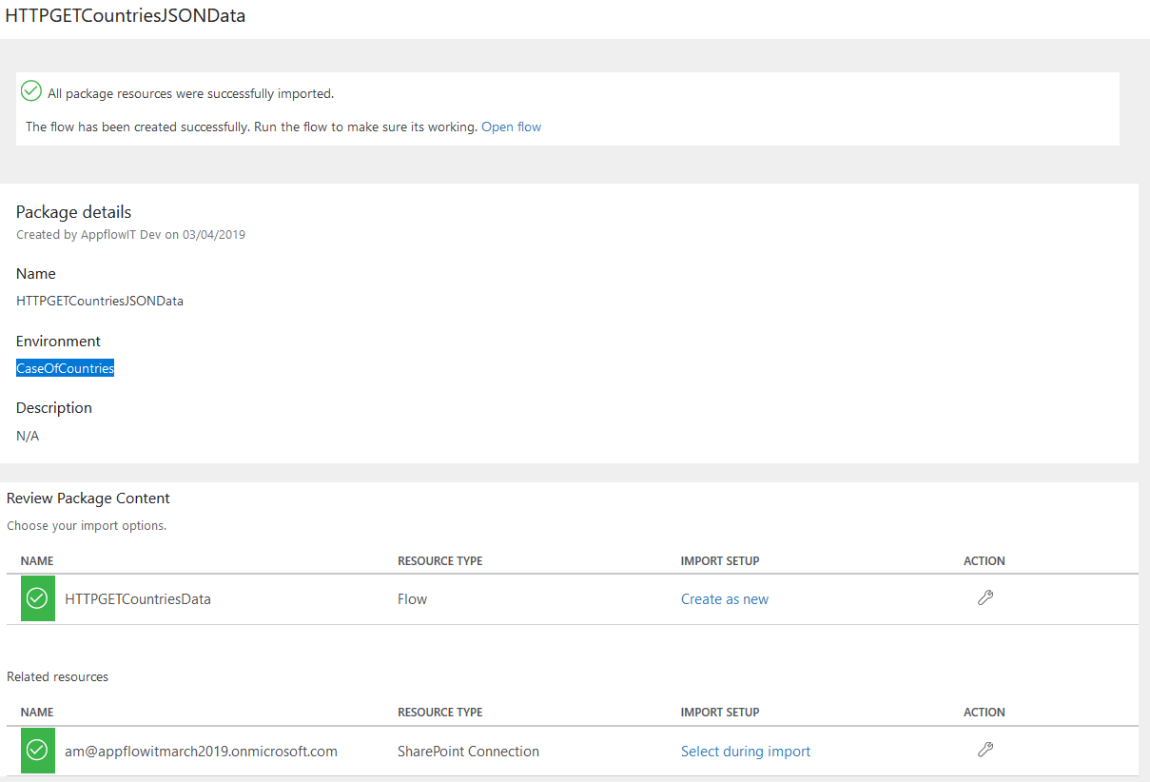

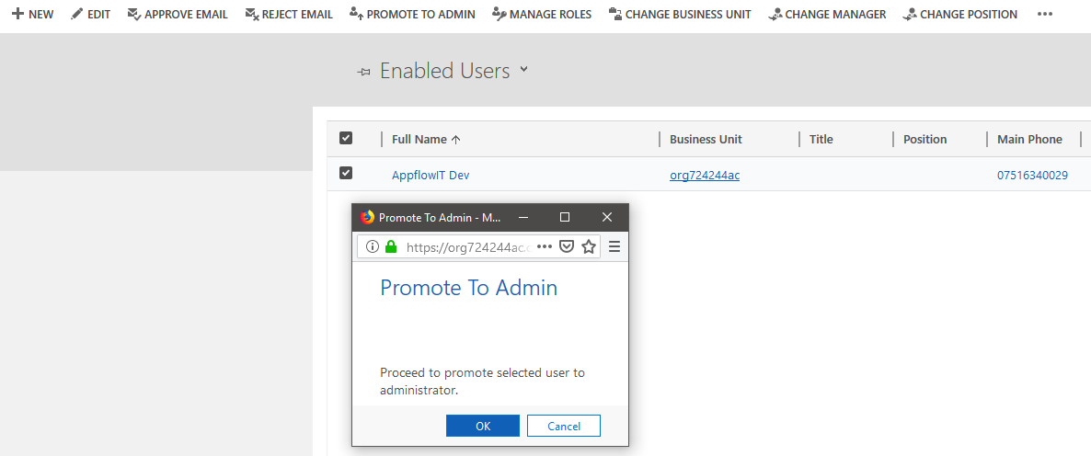

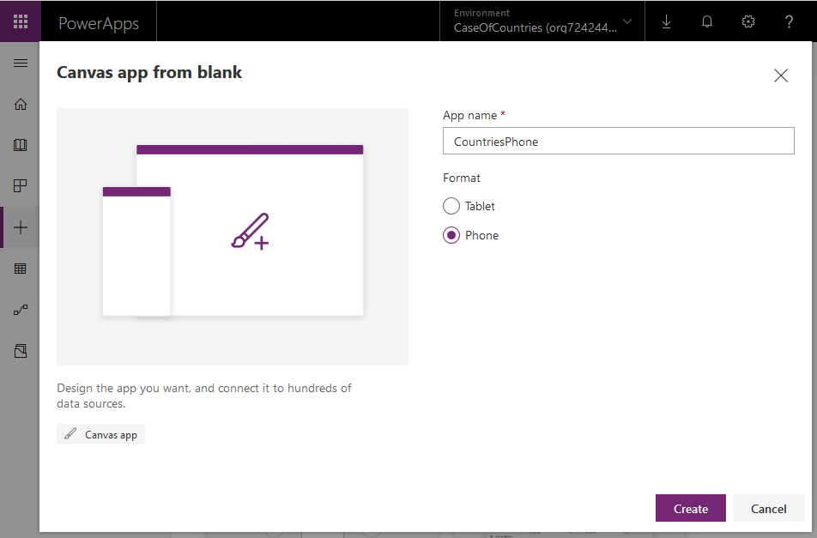 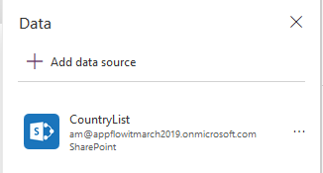

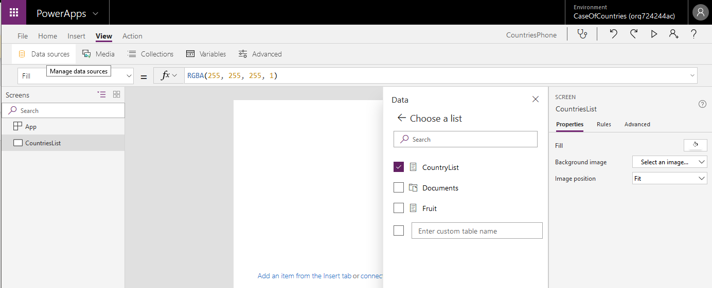

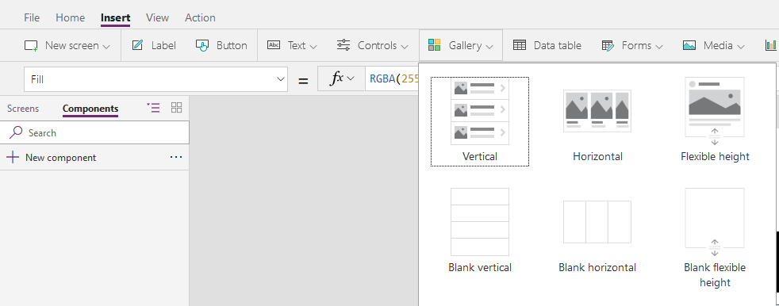

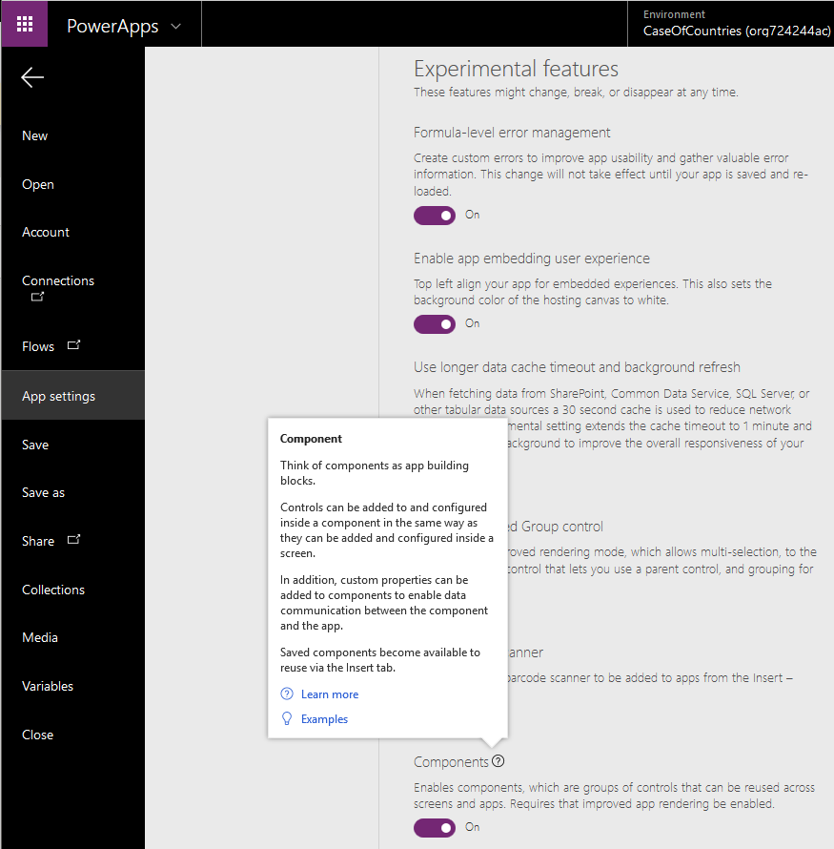

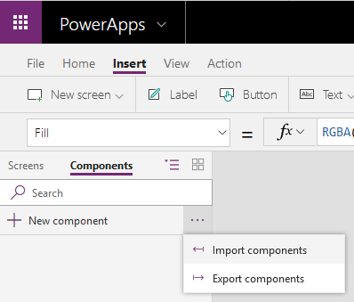 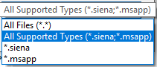

**Blog:** [**https://powerapps.microsoft.com/en-us/blog/powerapps-ten-reusable-components/**](https://powerapps.microsoft.com/en-us/blog/powerapps-ten-reusable-components/)

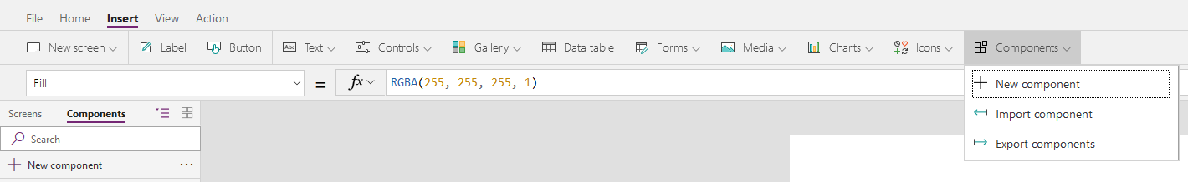

**Components in PowerApps:** [**https://github.com/Microsoft/powerapps-tools/tree/master/Components**](https://github.com/Microsoft/powerapps-tools/tree/master/Components)

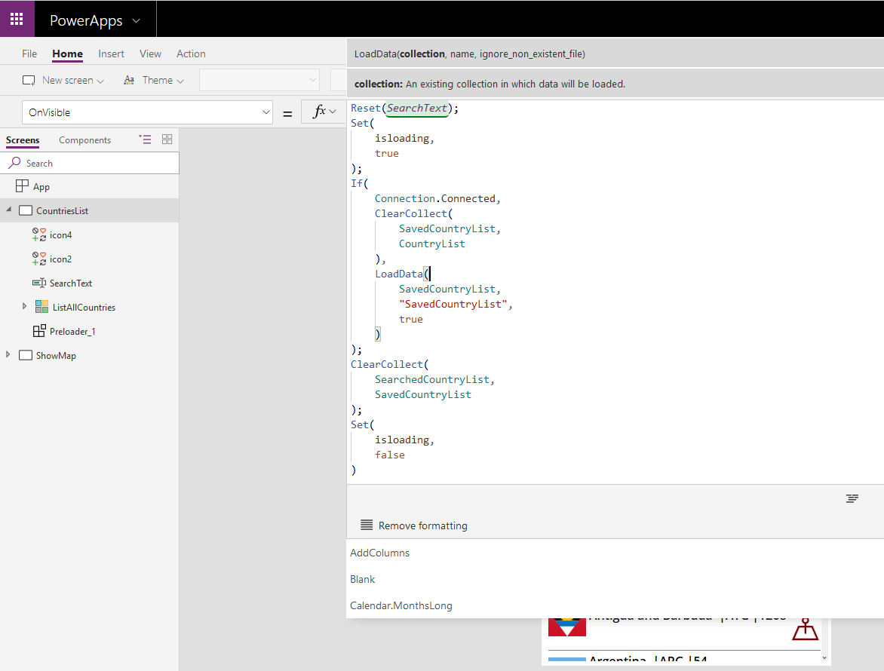

OFFLINE DATA: [**https://docs.microsoft.com/en-us/powerapps/maker/canvas-apps/offline-apps**](https://docs.microsoft.com/en-us/powerapps/maker/canvas-apps/offline-apps)

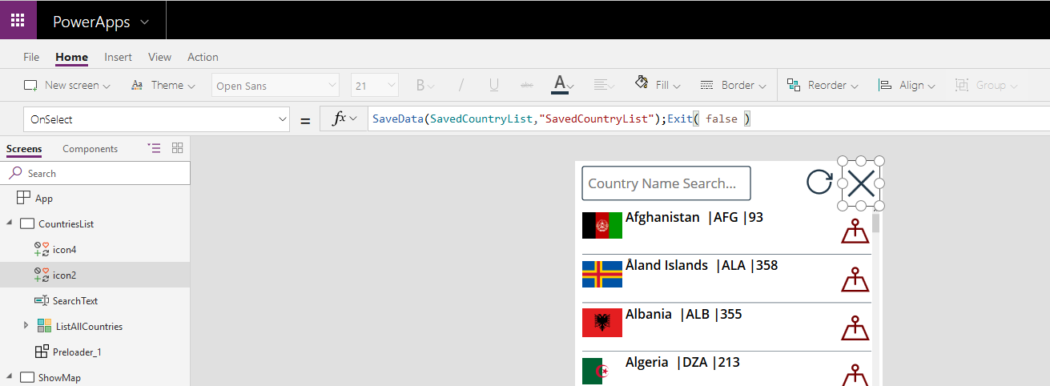

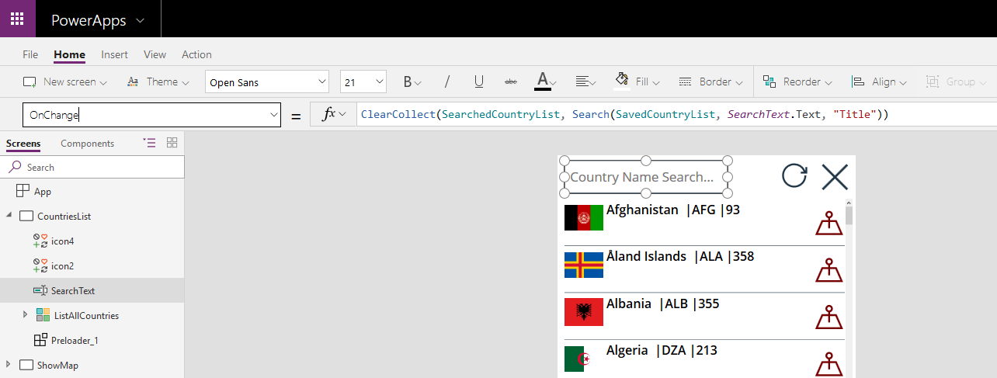

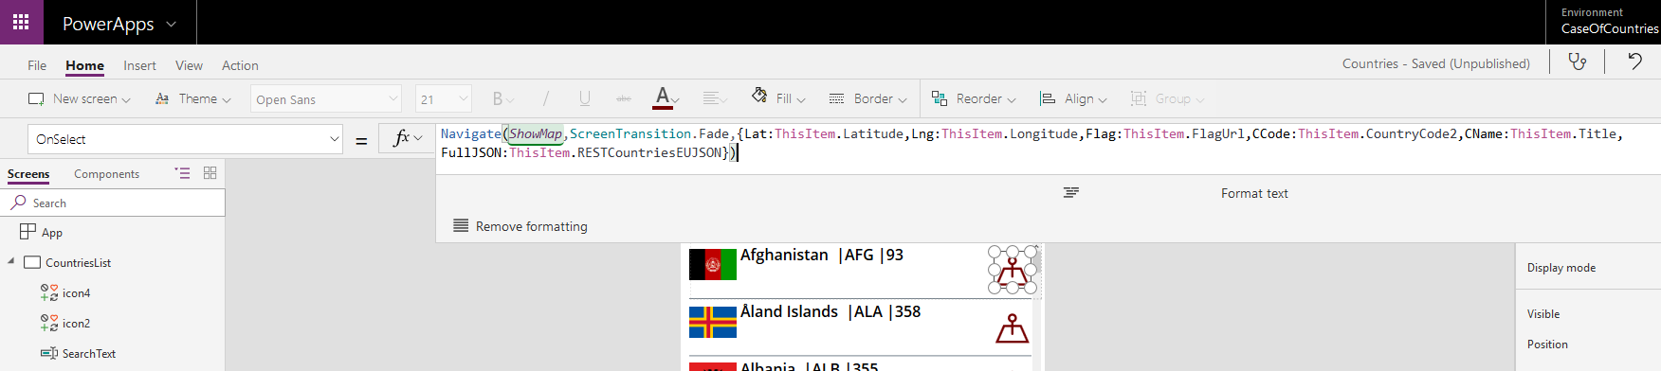

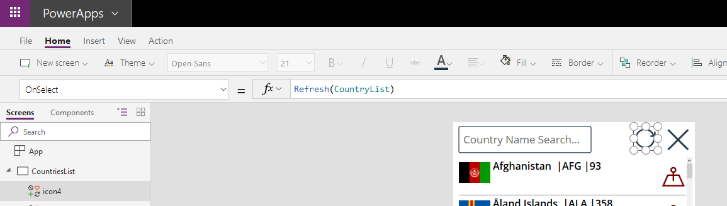

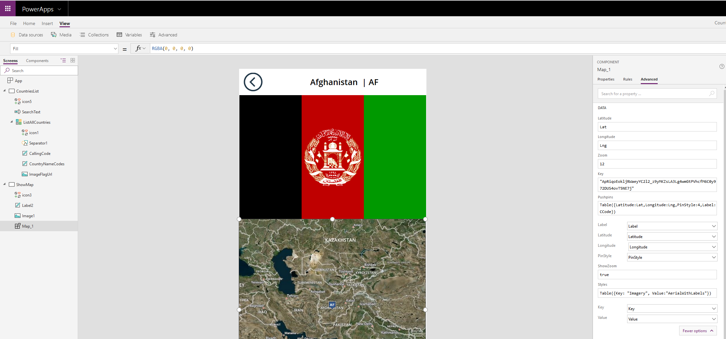

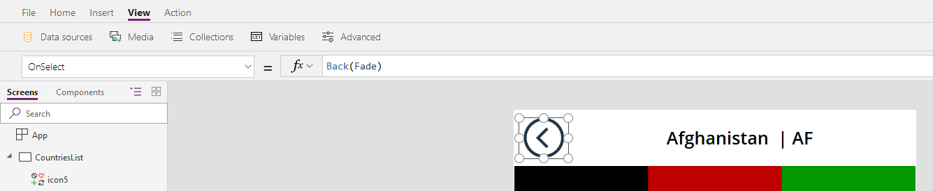

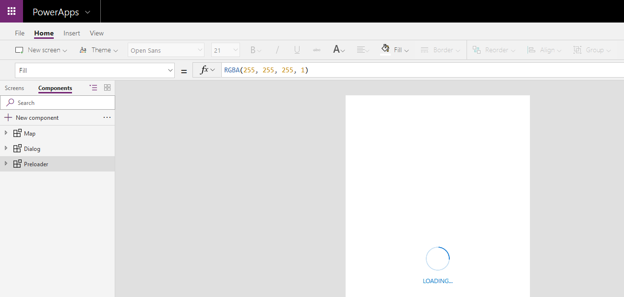

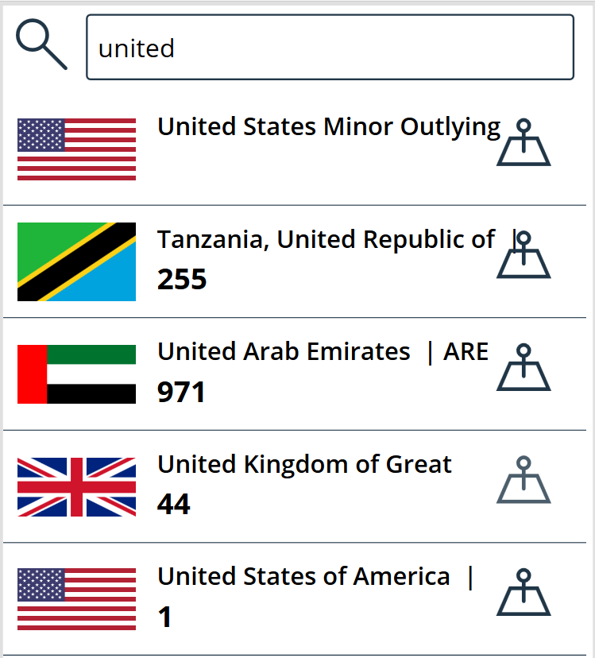 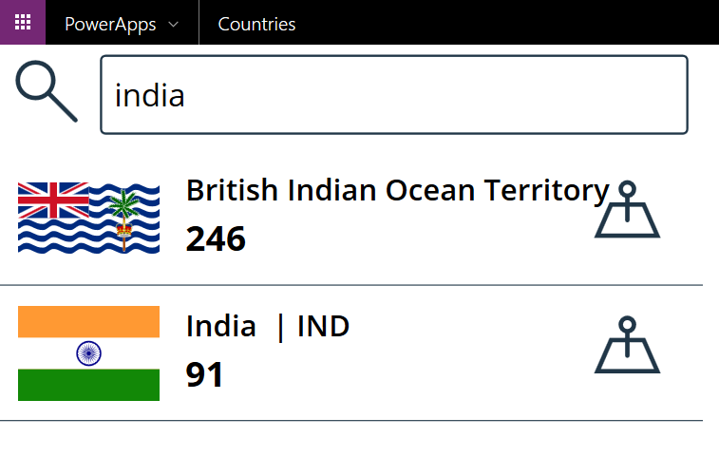

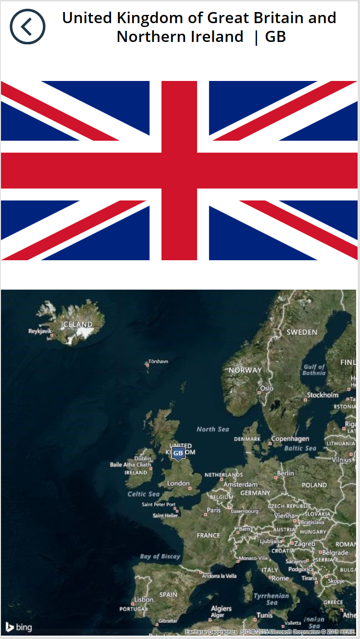 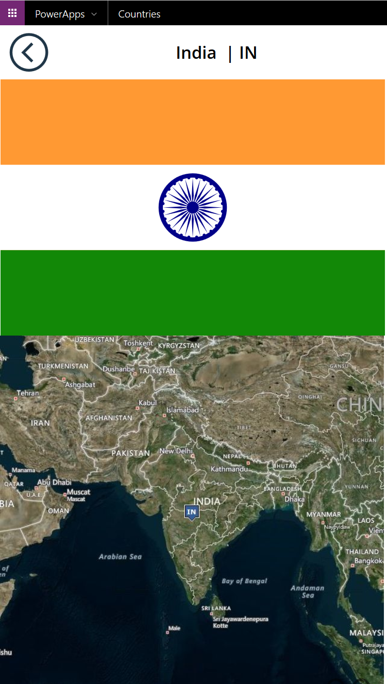

## QnA Maker BOT

**https://www.qnamaker.ai**

[**https://docs.microsoft.com/en-us/azure/cognitive-services/qnamaker**](https://docs.microsoft.com/en-us/azure/cognitive-services/qnamaker)

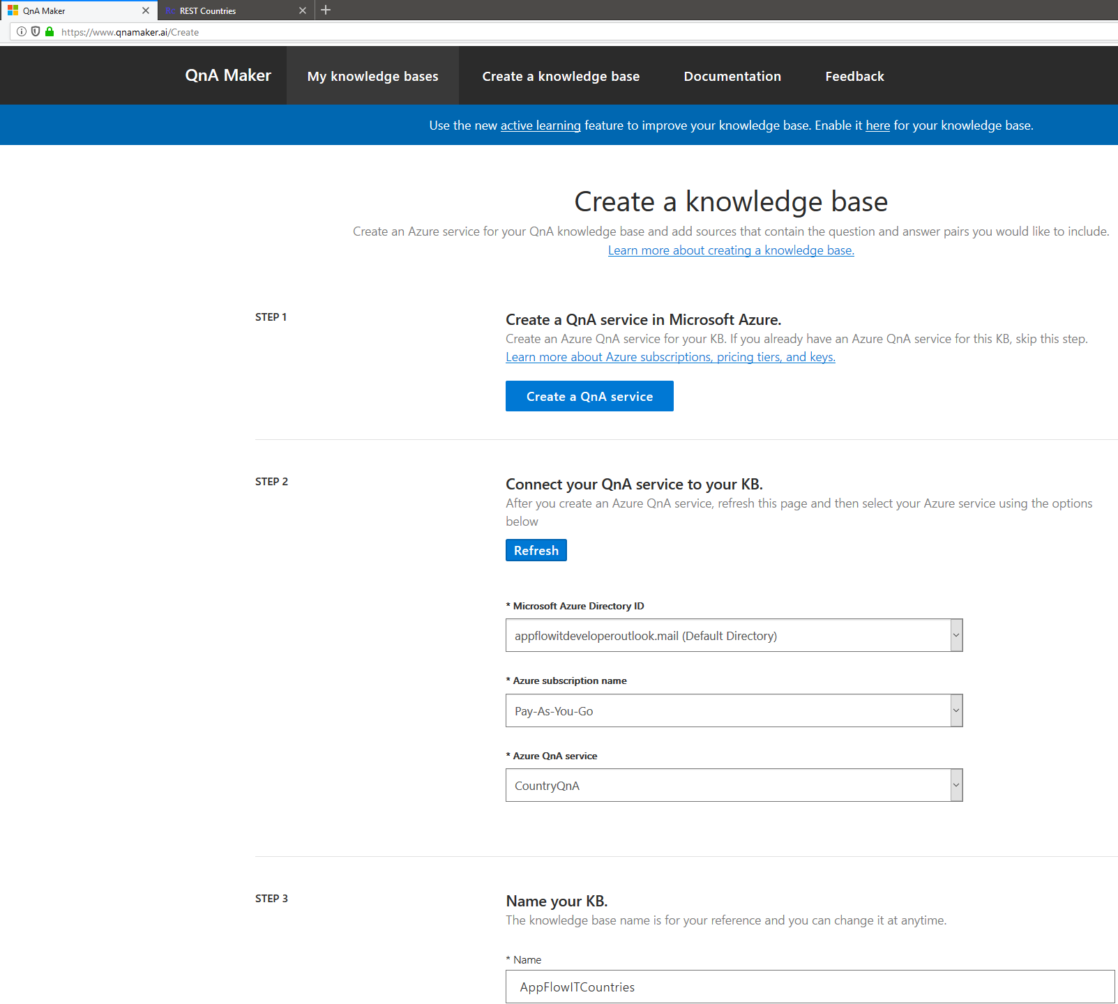 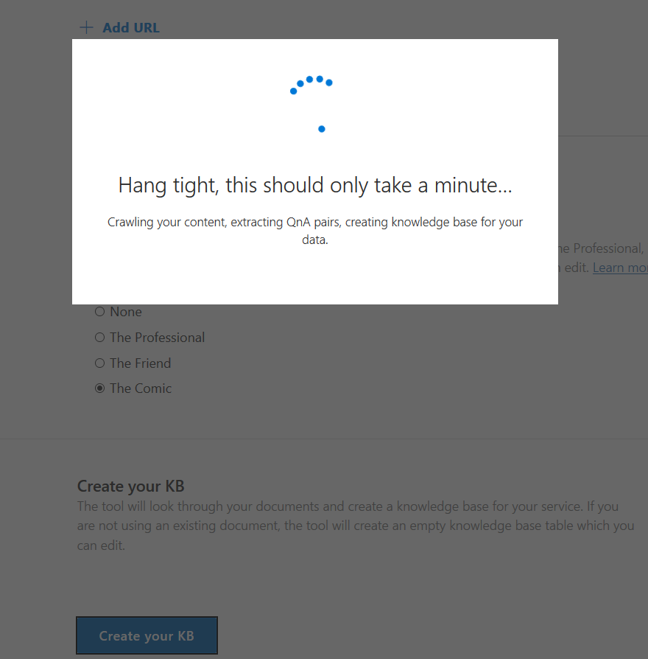

**Next Steps:** Download the file from OneDrive and Upload it to “CountryQnA” knowledge base from the Settings (with Add file option) from the <https://www.qnamaker.ai/Edit/Settings> logged in page.

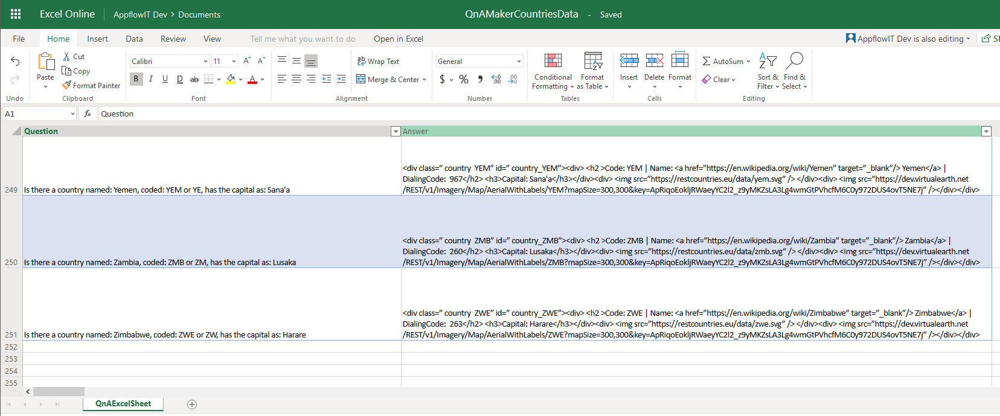

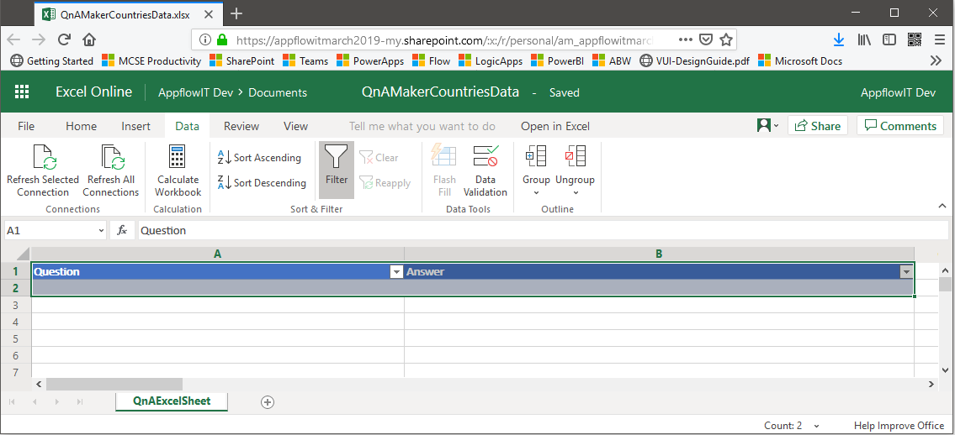

<div class=” country @{items('Apply_to_each')['alpha3Code']}” id=” country_@{items('Apply_to_each')['alpha3Code']}”>

<div>

<h2 > @{items('Apply_to_each')['alpha3Code']} | <a href=”https://en.wikipedia.org/wiki/@{items('Apply_to_each')['name']}” target=”_blank”/> @{items('Apply_to_each')['name']}</a> | @{first(items('Apply_to_each')['callingCodes'])}

</h2>

</div>

<div>

<img src=”@{items('Apply_to_each')['flag']}” />

</div>

<div>

<img src=”https://dev.virtualearth.net/REST/v1/Imagery/Map/AerialWithLabels/@{items('Apply_to_each')['alpha3Code']}?mapSize=300,300&key=ApRiqoEokljRWaeyYC2l2_z9yMKZsLA3Lg4wmGtPVhcfM6C0y972DUS4ovT5NE7j” />

</div>

</div>

*** NOTE: Adaptive Cards when introduced later stages or iterations – will mean changes across the Flow and UI-Clients.

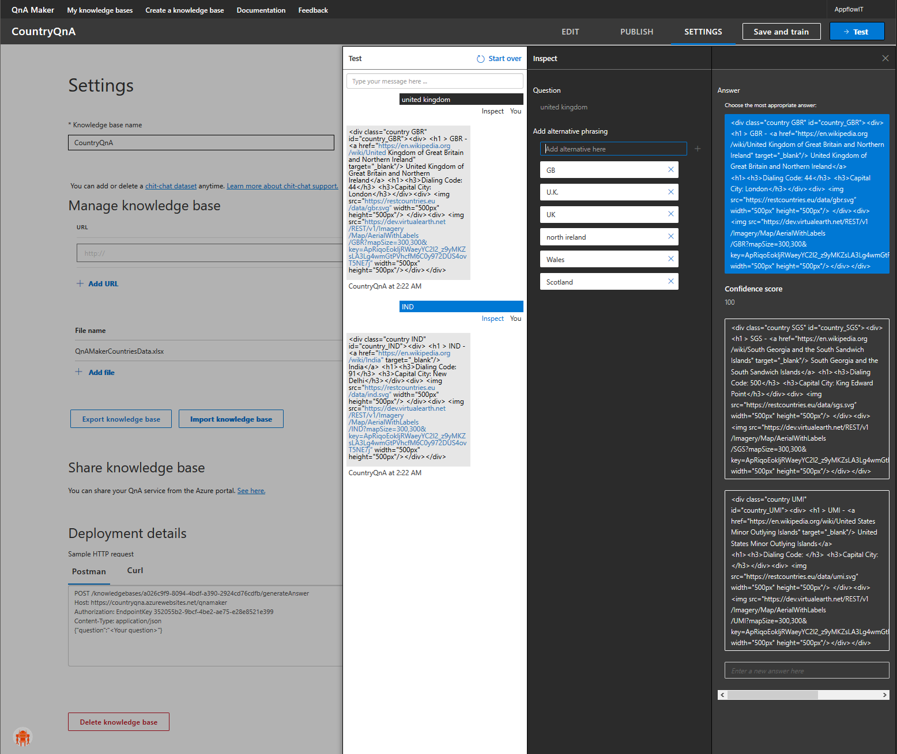

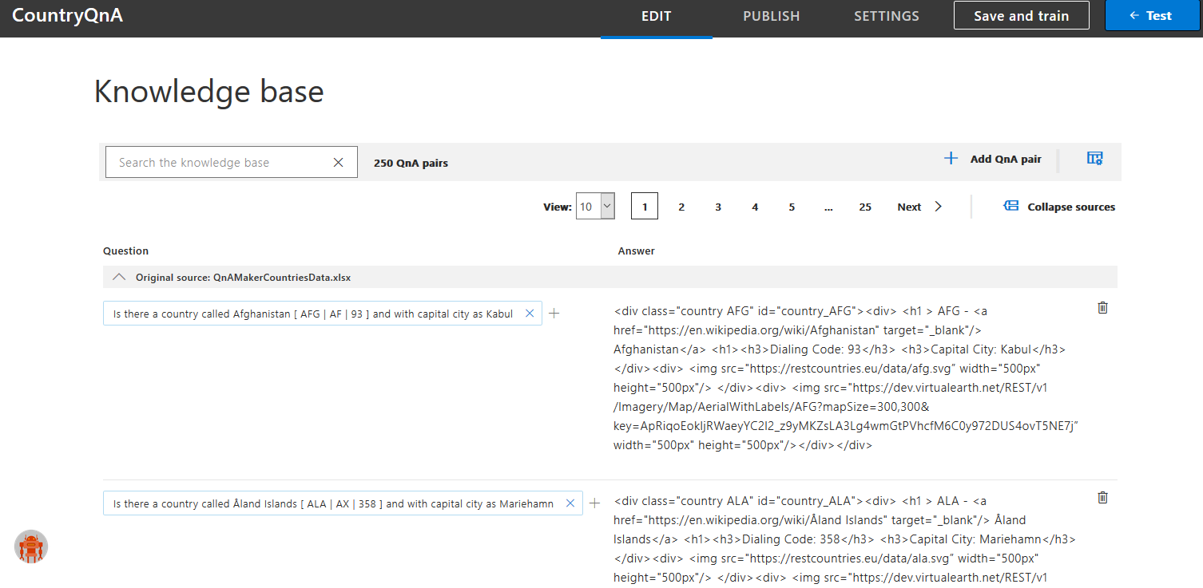

Next, Press [Save and train] button. Next, Publish the bot – which also gives a Postman querying sample shown in action below (with Postman Google-Chrome):

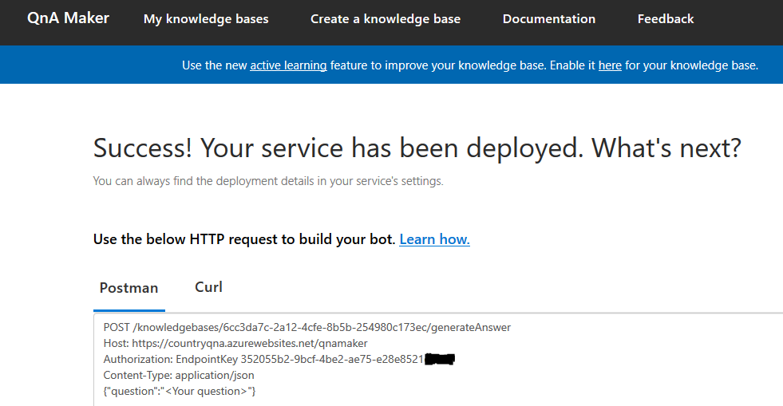

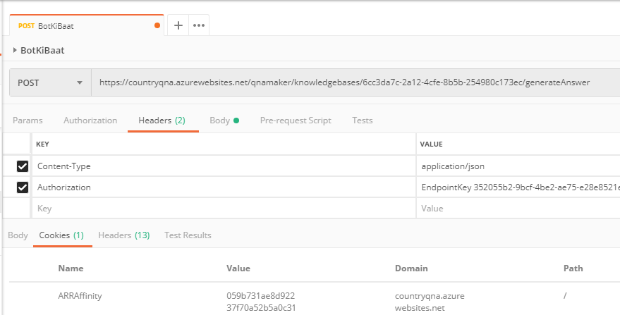

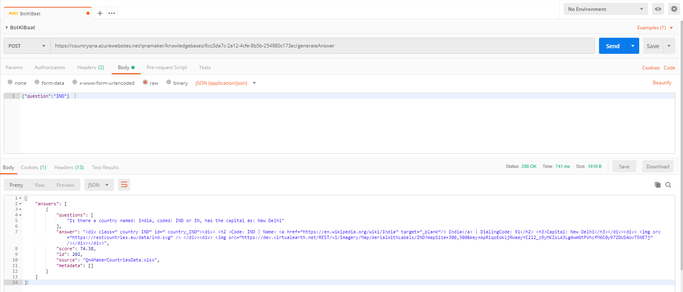

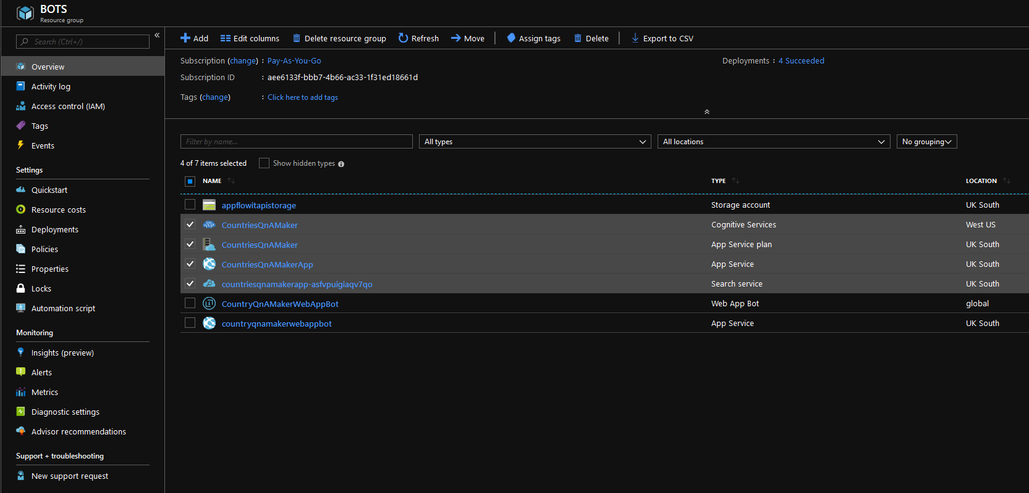

### **OPT1 – PowerApps & FLOW**

Using the QnA Maker Bot Knowledge-Base

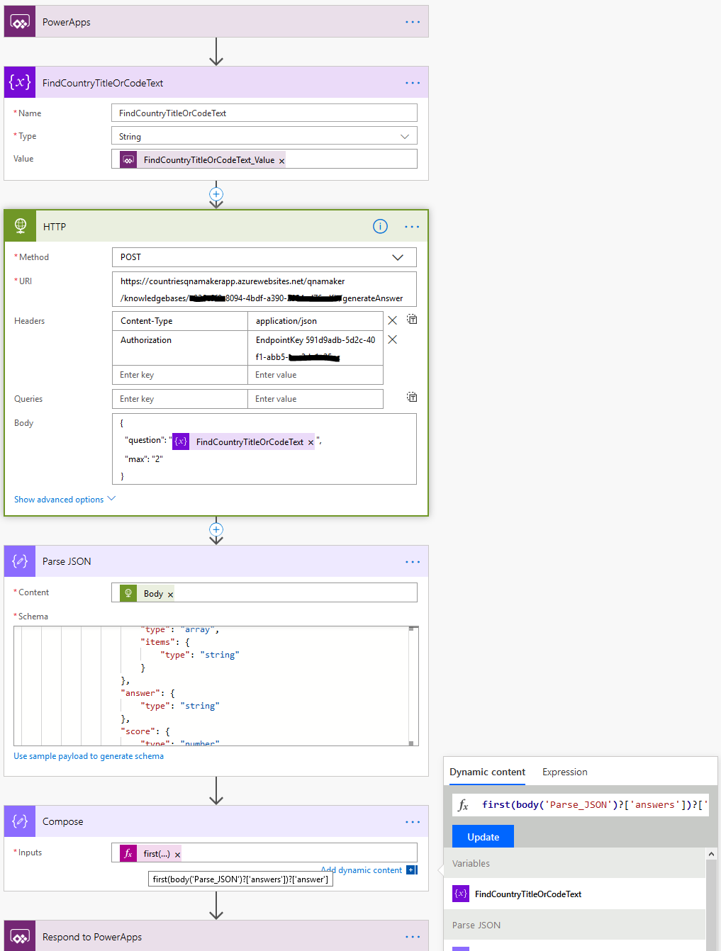

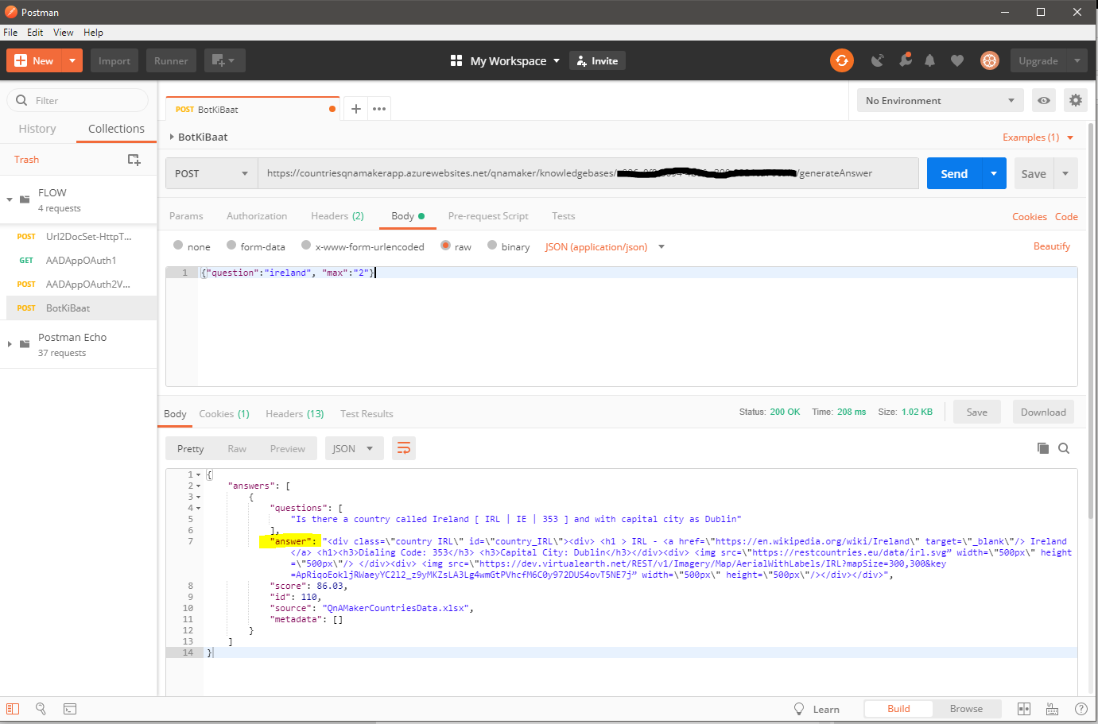

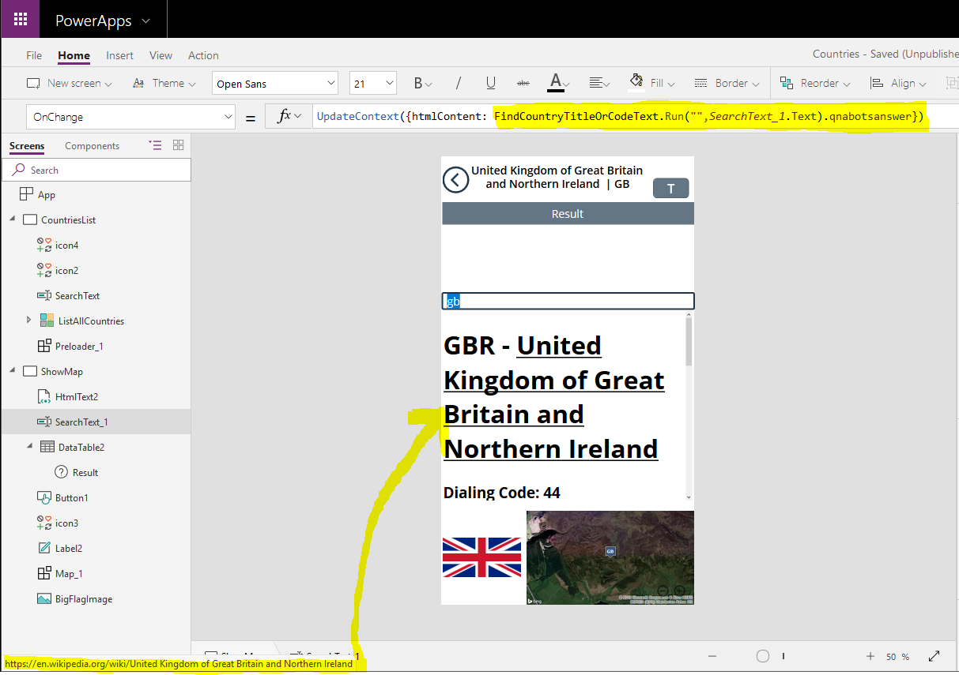

### **OPT2 – Azure Web Bot**

Using the QnA Maker Bot Knowledge-Base

<https://docs.microsoft.com/en-us/azure/bot-service/bot-builder-howto-qna?view=azure-bot-service-4.0&tabs=cs>

So, based on above ms-docs references – it is clear that using QnA Maker is a facility to create a intelligent-search and also facilitate creating a general purpose and flexible FAQ (Question-Answer) knowledge-base-data- store-and-model. So, the QnA Maker Azure service does not have abilty to host the chat-bot interface and so, if for instance multiple channel integration and other bot-features integration is needed to use the QnA Model – A “Web App Bot” is needed with many-few additional steps including deep coding (MORE CODE APPROACHING!) as follows:

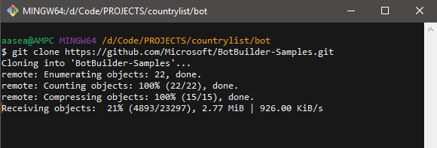

[**https://github.com/Microsoft/BotBuilder-Samples/tree/master/samples/csharp_dotnetcore/11.qnamaker/**](https://github.com/Microsoft/BotBuilder-Samples/tree/master/samples/csharp_dotnetcore/11.qnamaker/)

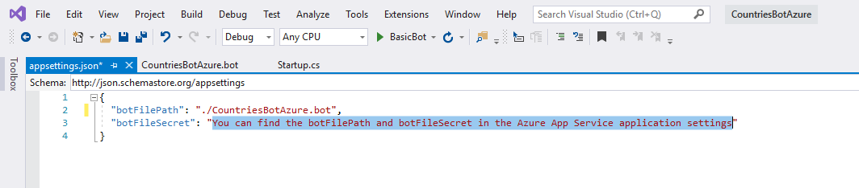

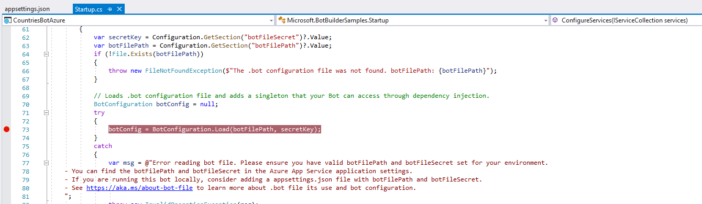

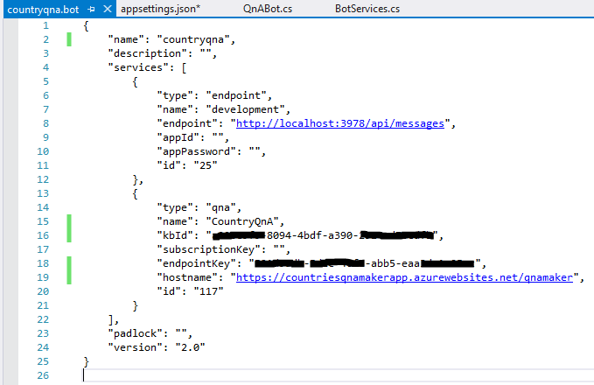

Ensuring: **Microsoft.Bot.Builder.AI.QnA** nuget package/library-namespace

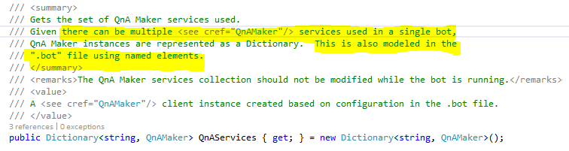

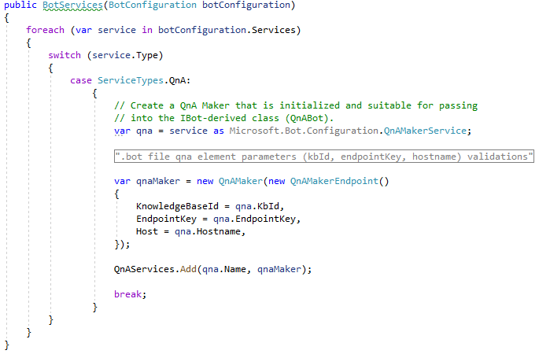

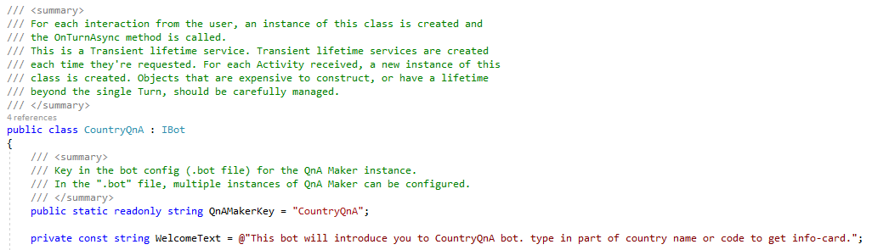

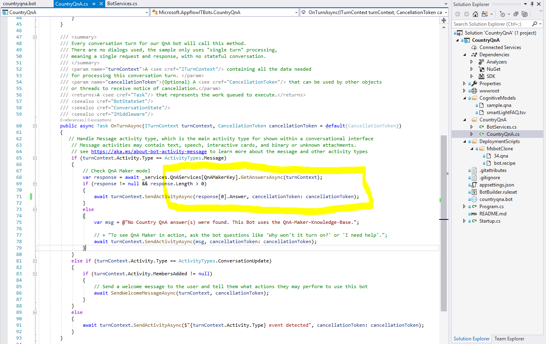

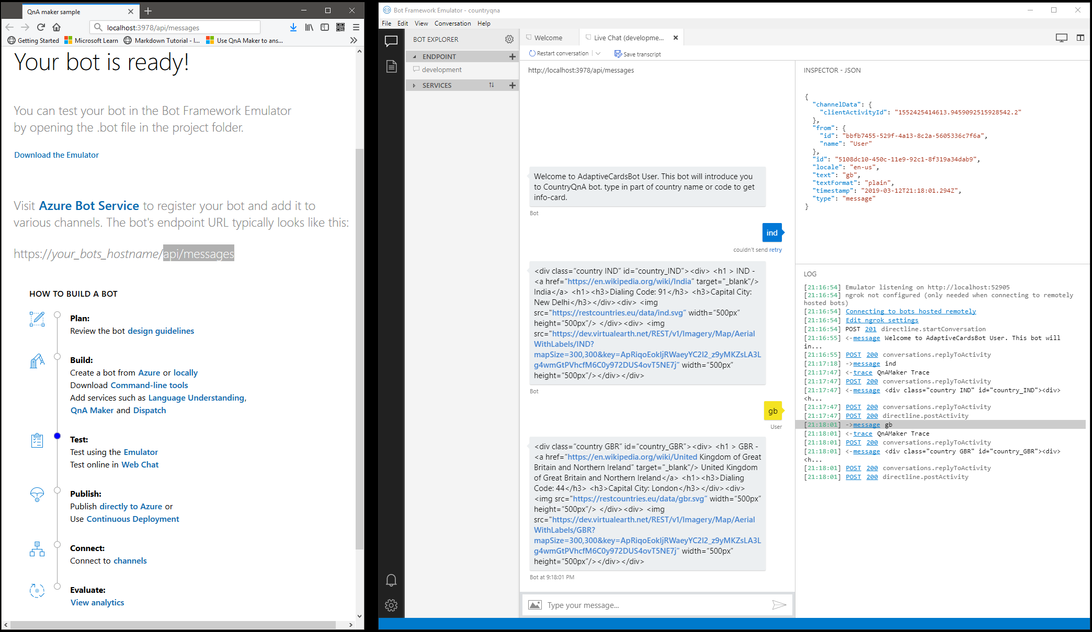

#### Using Adaptive “Cards”

Design Schema/UI once use many places -> Bot Webchat, Outlook Actionable Message, MS-Teams, Cortana skills, Skype

https://adaptivecards.io/

|  |  |
| --- | --- |
| Visualizer  Designer | <https://adaptivecards.io/visualizer/index.html>  <https://adaptivecards.io/designer> |
| Schema Explorer | [**https://adaptivecards.io/explorer/**](https://adaptivecards.io/explorer/) |
| Adaptive Cards for Bot framework | <https://docs.microsoft.com/en-gb/adaptive-cards/getting-started/bots#channel-status> |
| Cards and Luis related samples | [**https://adaptivecards.io/samples/**](https://adaptivecards.io/samples/)  <https://github.com/Microsoft/BotBuilder-Samples/tree/master/samples/csharp_dotnetcore> |
| Other refs | [**https://messagecardplayground.azurewebsites.net/**](https://messagecardplayground.azurewebsites.net/)  <https://blog.botframework.com/2017/08/25/qna-maker-rich-card-attachments-net/> |

*Sample code and run shown below:*

|  |  |
| --- | --- |
|  |  |
|  |

Now, Upgrading the QnA Bot KB with Adaptive Card format answer – to plug right in to the Azure Bot

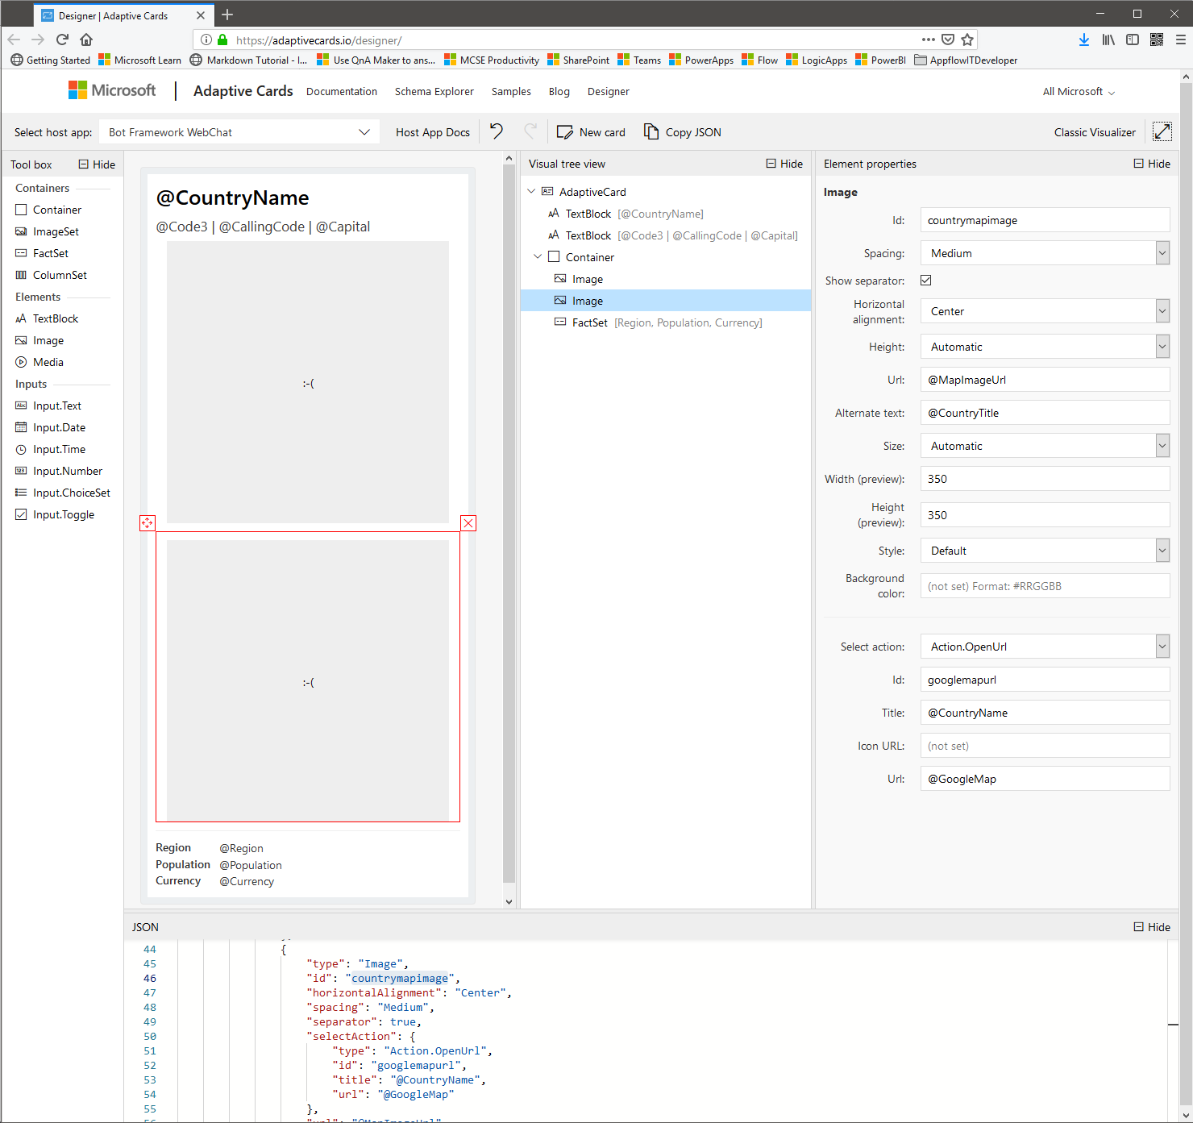

[**https://adaptivecards.io/visualizer/index.html**](https://adaptivecards.io/visualizer/index.html)

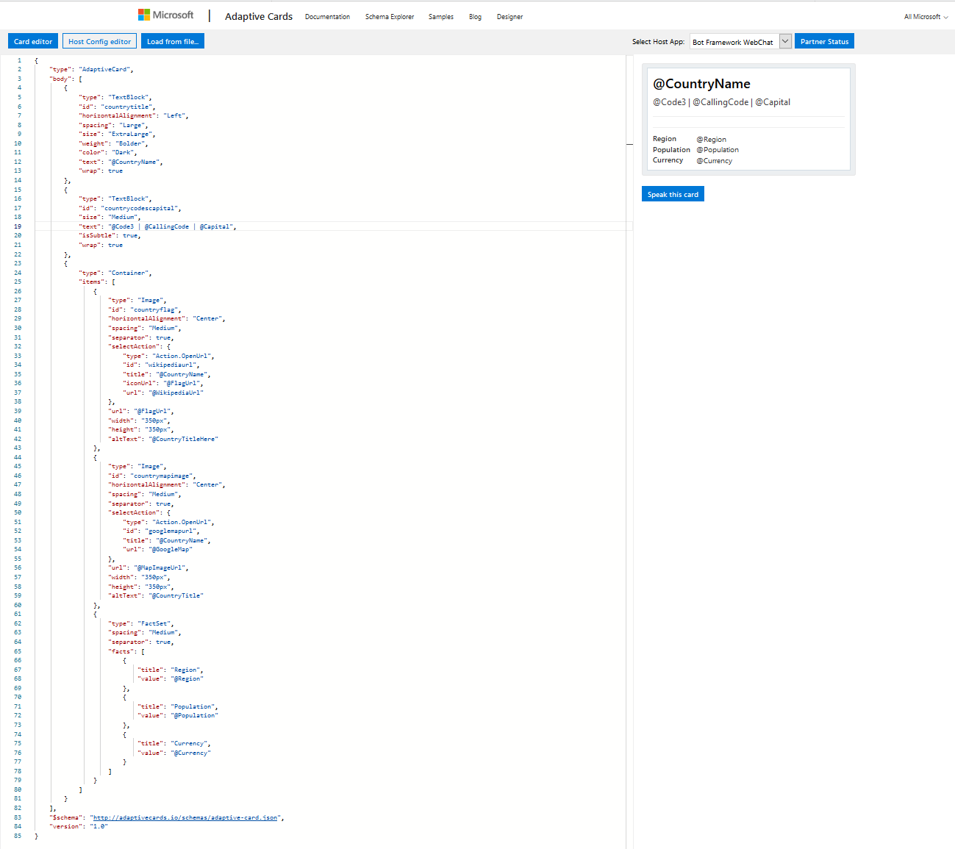

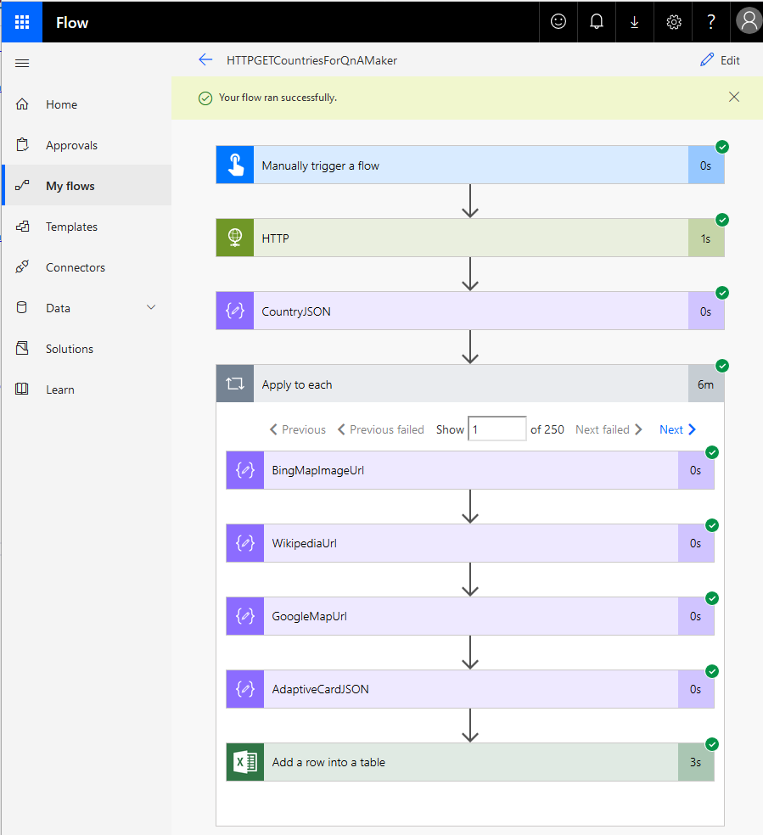 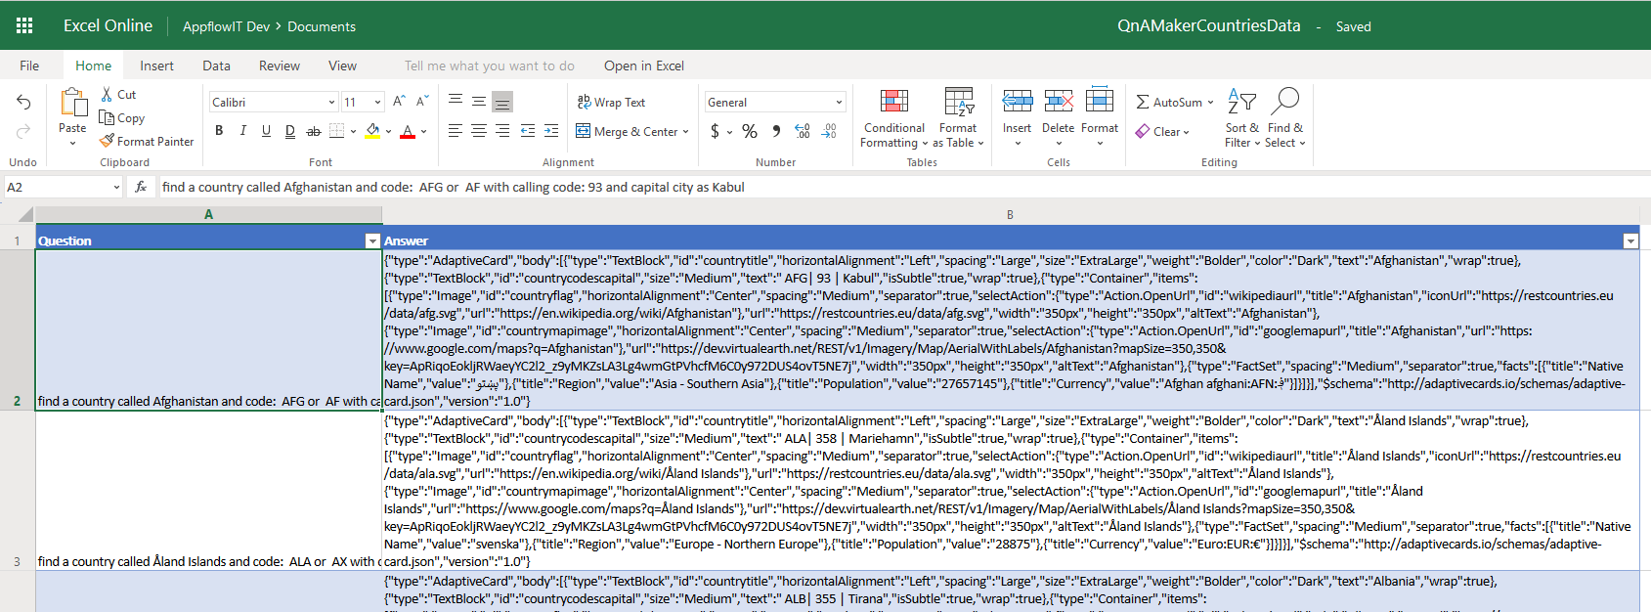

Go to <https://www.qnamaker.ai/Home/MyServices> deleting the existing excel file from Settings for “CountryQnA” Kb and Save+Train .. Then uploading the new file downloaded from OneDrive and Save+Train =>Publish. See result in Visualizer..

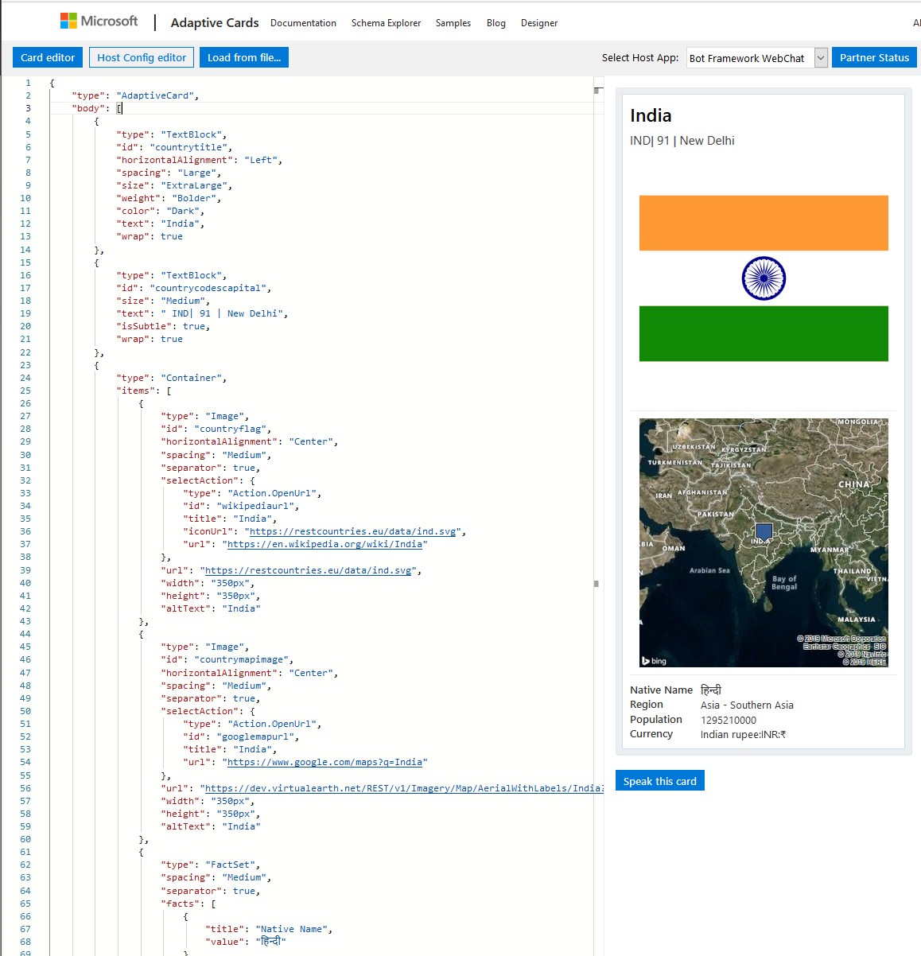

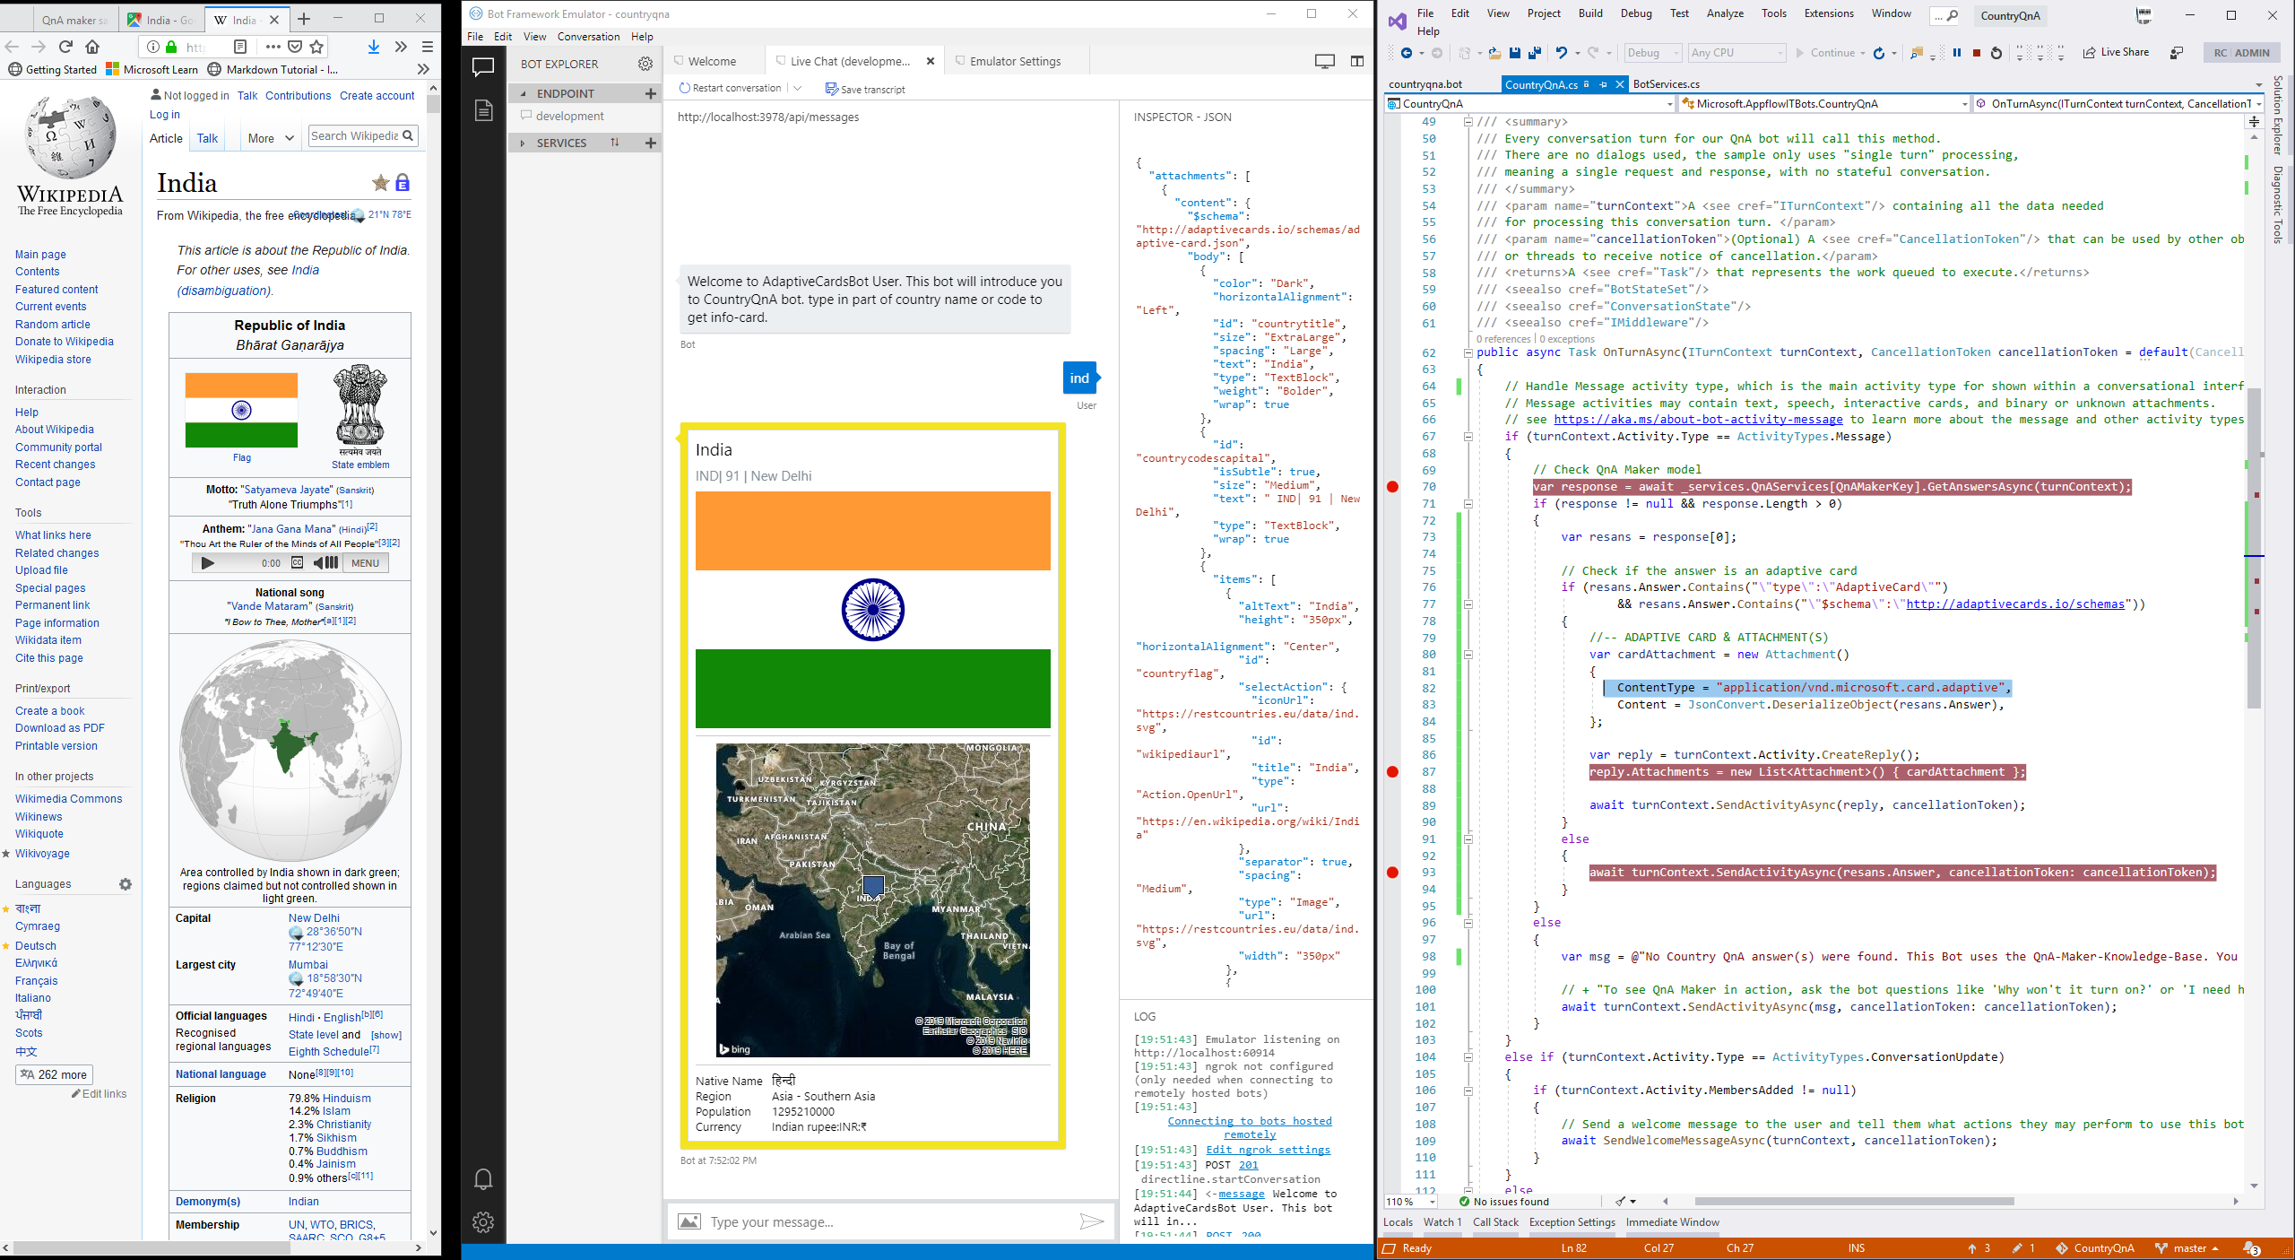

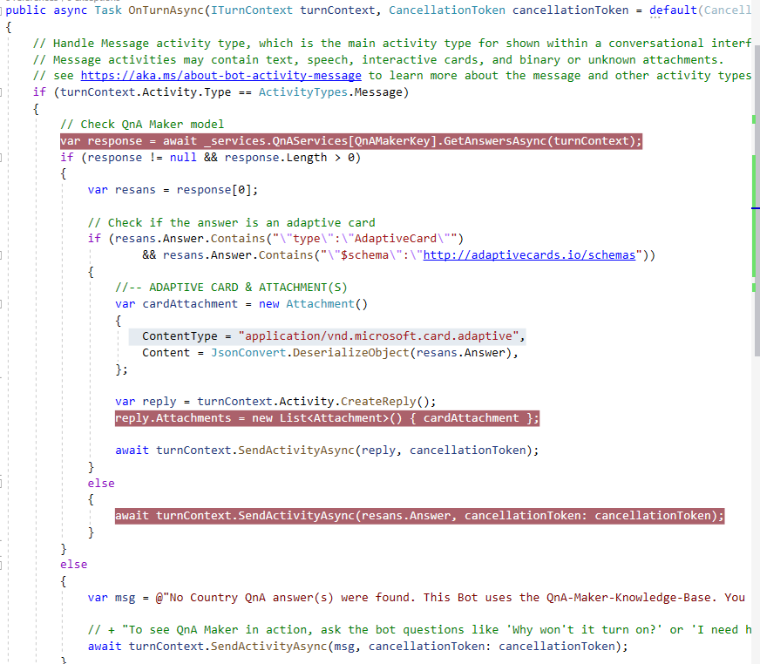

#### Setup Azure Web-App for Bots

Now, Publishing the locally developed bot to Azure Bot Web App for deployment and towards additional channel integration

|  |  |
| --- | --- |
| [**https://docs.microsoft.com/en-us/azure/bot-service/bot-service-quickstart?view=azure-bot-service-4.0**](https://docs.microsoft.com/en-us/azure/bot-service/bot-service-quickstart?view=azure-bot-service-4.0)  *The deployment process requires a target Web App Bot in Azure so that your local bot can be deployed into it.* | |
| **Bot development workflow & tools** | [**https://github.com/Microsoft/botbuilder-tools/blob/master/tools-overview.md#tools-overview**](https://github.com/Microsoft/botbuilder-tools/blob/master/tools-overview.md#tools-overview)  Step1: **npm** install **-g** msbot chatdown luisgen ludown luis-apis botdispatch qnamaker |
| **Install Azure CLI** | [**https://docs.microsoft.com/en-us/cli/azure/install-azure-cli-windows?view=azure-cli-latest**](https://docs.microsoft.com/en-us/cli/azure/install-azure-cli-windows?view=azure-cli-latest) |
| **Bot deployment:** [**https://docs.microsoft.com/en-gb/azure/bot-service/bot-builder-deploy-az-cli?view=azure-bot-service-4.0**](https://docs.microsoft.com/en-gb/azure/bot-service/bot-builder-deploy-az-cli?view=azure-bot-service-4.0)   * **Download the bot code from the Azure portal to your local machine, to get service references that are in the** [**.bot file**](https://docs.microsoft.com/en-gb/azure/bot-service/bot-file-basics?view=azure-bot-service-4.0) **- for Web App Bot, App Service Plan, App Service, and Storage Account. Then, manually merge into the local project from before...** * When downloading your bot, you will be given the option to include the settings (containing the keys and secrets) for your bot in your download, which may be necessary for your bot to work. If you choose **Yes**, the **appsettings.json** or .env file will have the keys.   [**https://github.com/Microsoft/botbuilder-tools/tree/master/packages/MSBot#msbot-functionality**](https://github.com/Microsoft/botbuilder-tools/tree/master/packages/MSBot#msbot-functionality)  [**Decrypt the .bot file**](https://docs.microsoft.com/en-gb/azure/bot-service/bot-builder-deploy-az-cli?view=azure-bot-service-4.0#decrypt-the-bot-file)  ***msbot secret --bot <bot-filename> --secret "<bot-file-secret>" --clear***   * Copy **all** entries listed under the ***services section*** and add them to your local .bot file. Ensure local files QnA Maker { qna } settings is also retained. * Optionally: *Use the msbot tool to generate a new secret and encrypt the .bot file before you publish. If you re-encrypt your .bot file, update the bot's* ***botFileSecret*** *in the Azure portal to contain the new secret:* ***msbot secret --bot <name-of-bot-file> --new*** | |
| **Continuous deployment** with Git/Azure DevOps repository and using Azure deployment center…  [**https://docs.microsoft.com/en-gb/azure/app-service/deploy-continuous-deployment#deploy-continuously-from-azure-repos-devops-services**](https://docs.microsoft.com/en-gb/azure/app-service/deploy-continuous-deployment#deploy-continuously-from-azure-repos-devops-services) |  |
|  |  |
|  |  |
|  | |
|  | |

|  |  |
| --- | --- |
| Channel #0: Test in Web Chat | Channel #1 : Embed in html |
|  |  |
|  | |
| ALEXA & LUIS integration coming soon!!! | |

## SPFX - Sharepoint Framework

### SPFX Toolchain|Environment

|  |  |  |  |  |
| --- | --- | --- | --- | --- |
| Setup environment  [https://docs.microsoft.com/en-us/sharepoint/dev/spfx/set-up-your-development-environment**#install-developer-tools**](https://docs.microsoft.com/en-us/sharepoint/dev/spfx/set-up-your-development-environment#install-developer-tools) | Supported Node-JS: [**https://nodejs.org/download/release/v8.15.1/node-v8.15.1-win-x64.zip**](https://nodejs.org/download/release/v8.15.1/node-v8.15.1-win-x64.zip)  ** To Note that 9.x or 10.x versions are currently not supported with SharePoint Framework development(April-2019) | | | |
| Typescript | Babel, Yoeman, Gulp | Webpack, Yeoman-SharePoint-generator  React : <https://reactjs.org/docs/create-a-new-react-app.html>  Typescript + React:  <https://www.typescriptlang.org/docs/handbook/react-&-webpack.html> | | <https://docs.microsoft.com/en-us/sharepoint/dev/spfx/set-up-your-development-environment#install-yeoman-and-gulp>  npm install -g typescript yo gulp @microsoft/generator-sharepoint  npm install -g webpack  npm i -g npx  *\*Trusting the self-signed developer certificate => and requires INSTALLING the certificate locally\**  gulp trust-dev-cert | | |
| Fabric UI & [**Adobe XD**](https://www.adobe.com/uk/products/xd.html)-CC Toolkit | | <https://developer.microsoft.com/en-us/fabric#/resources>  <https://developer.microsoft.com/en-us/fabric#/components>  [**https://youtu.be/Kj3cfHFgczs**](https://youtu.be/Kj3cfHFgczs)  [**https://app.pluralsight.com/library/courses/adobe-xd-cc-fundamentals**](https://app.pluralsight.com/library/courses/adobe-xd-cc-fundamentals) | | |
| [PnPjs](https://pnp.github.io/pnpjs/)  ** SharePoint Framework, Nodejs, or any JavaScript  **https://pnp.github.io/pnpjs** | | PnPjs is a collection of fluent libraries for consuming SharePoint, Graph, and Office 365 REST APIs in a type-safe way.  **npm** install [**@pnp/common**](https://pnp.github.io/pnpjs/common/docs/)[**@pnp/logging**](https://pnp.github.io/pnpjs/logging/docs/) **@pnp/odata** [**@pnp/sp**](https://pnp.github.io/pnpjs/sp/docs/)[**@pnp/graph**](https://pnp.github.io/pnpjs/graph/docs/) **--save**  To use terms-store-taxonomy after above packages are installed:  npm install [**@pnp/sp-taxonomy**](https://pnp.github.io/pnpjs/sp-taxonomy/docs/) @pnp/sp-clientsvc --save | | |
| ***Dependency:*** [SharePoint Online Client Components SDK](https://www.microsoft.com/en-gb/download/details.aspx?id=42038)  SharePoint Online: Management  Shell   * [**SharePoint Online Management Shell**](https://support.office.com/en-gb/article/introduction-to-the-sharepoint-online-management-shell-c16941c3-19b4-4710-8056-34c034493429) * [**Download**](https://www.microsoft.com/en-us/download/details.aspx?id=35588) | | | | |
| VS-Code extensions | | | |  | |
| [VS-Code Debugging](https://docs.microsoft.com/en-us/sharepoint/dev/spfx/debug-in-vscode) : CHROME/EDGE | | | | <https://docs.microsoft.com/en-us/sharepoint/dev/spfx/debug-in-vscode#debug-extension-solution-using-hosted-workbench> | |
| Office-CLI: <https://pnp.github.io/office365-cli/>  [**https://github.com/pnp/office365-cli**](https://github.com/pnp/office365-cli) | | | | |
| **CDN Setup**  [**https://docs.microsoft.com/en-us/sharepoint/dev/general-development/office-365-cdn**](https://docs.microsoft.com/en-us/sharepoint/dev/general-development/office-365-cdn)  Pluralsight (Management Power/shell): [Sahil Malik](https://app.pluralsight.com/player?course=sharepoint-framework-extensions&author=sahil-malik&name=43c1d599-1bf8-4d5f-9202-c087bf682c34&clip=3&mode=live)  Get-Command -Module Microsoft.Online.SharePoint.PowerShell | Where-Object {$_.Name -like '*cdn*'} | Select Name  <#    Get-SPOPublicCdnOrigins  New-SPOPublicCdnOrigin  Remove-SPOPublicCdnOrigin  Add-SPOTenantCdnOrigin  Get-SPOTenantCdnEnabled  Get-SPOTenantCdnOrigins  Get-SPOTenantCdnPolicies  Set-SPOTenantCdnEnabled  Set-SPOTenantCdnPolicy  Remove-SPOTenantCdnOrigin  #>  [**https://pnp.github.io/office365-cli/cmd/spo/cdn/cdn-get/**](https://pnp.github.io/office365-cli/cmd/spo/cdn/cdn-get/) | | | **PnP(PowerShell):** [**https://www.youtube.com/watch?v=2kI2LnQ-3wQ**](https://www.youtube.com/watch?v=2kI2LnQ-3wQ)  Get-SPOTenantCdnEnabled -CdnType Public  Set-SPOTenantCdnEnabled -CdnType Public -Enable $true  Get-SPOTenantCdnOrigins -CdnType Public  ##The origin is a URL that points to a SharePoint library or folder that contains the assets that you want to be hosted by the CDN.  Add-SPOTenantCdnOrigin -CdnType Public -OriginUrl "/sites/Countries/SiteAssets/countrylist"  Get-SPOTenantCdnPolicies -CdnType Public  Set-SPOTenantCdnPolicy -CdnType Public -PolicyType IncludeFileExtensions -PolicyValue "CSS,EOT,GIF,ICO,JPEG,JPG,JS,MAP,PNG,SVG,TTF,WOFF,JSON"  <# Removing a CDN origin doesn't affect the files stored in any Document library matching that origin. If these assets have been referenced using their SharePoint URL, SharePoint will automatically switch back to the original URL pointing to the Document library. If, however, assets have been referenced using the Public CDN URL, then these links will now be broken and will need to be manually changed. It's not possible to modify an existing CDN origin, so Remove and Add should be used instead#>  ## Remove-SPOTenantCdnOrigin -CdnType Public -OriginUrl */masterpage      **O365-CLI :** [**https://youtu.be/ngWO1DwMqsI?t=450**](https://youtu.be/ngWO1DwMqsI?t=450)    spo cdn **get** --type Public  spo cdn **set** --type Public --enabled true  spo cdn **origin** **list** --type Public  spo cdn **origin** **add** --type Public –origin /sites/Countries/SiteAssets/countrylist  spo cdn **origin** **remove** --type Public --origin */masterpage  spo cdn **policy** **list**  spo cdn policy set --type Public --policy IncludeFileExtensions --value "CSS,EOT,GIF,ICO,JPEG,JPG,JS,MAP,PNG,SVG,TTF,WOFF,JSON"  spo cdn policy **set** --type Public --policy ExcludeRestrictedSiteClassifications --value "HBI"  spo cdn **set** --type Public --enabled false | |
| **App-Catalog @Tenant:**  [https://**social.technet.microsoft.com/wiki**/contents/articles/36933.create-app-catalog-in-sharepoint-online.aspx](https://social.technet.microsoft.com/wiki/contents/articles/36933.create-app-catalog-in-sharepoint-online.aspx)  [https://docs.microsoft.com/en-us/sharepoint/use-app-catalog**#step-1-create-the-app-catalog-site-collection**](https://docs.microsoft.com/en-us/sharepoint/use-app-catalog#step-1-create-the-app-catalog-site-collection)    **App-Catalog @Site-Collection:**  [**https://docs.microsoft.com/en-us/sharepoint/dev/general-development/site-collection-app-catalog#create-a-site-collection-app-catalog**](https://docs.microsoft.com/en-us/sharepoint/dev/general-development/site-collection-app-catalog#create-a-site-collection-app-catalog)  Ensure, that you have a *tenant app catalog* created in your tenant. If not following error occurs:  Add-SPOSiteCollectionAppCatalog : Cannot invoke method or retrieve property from null object. Object returned by the following call stack is null. "TenantAppCatalog  RootWeb  GetSiteByUrl new Microsoft.Online.SharePoint.TenantAdministration.Tenant()  #### Tenant App Catalog Site (Created) : https://appflowitmarch2019.sharepoint.com/sites/appcatalog  Get-Command -Module Microsoft.Online.SharePoint.PowerShell | Where-Object {$_.Name -like '*cata*'} | Select Name  <#  Name  ----  Add-SPOSiteCollectionAppCatalog  Get-SPOSiteCollectionAppCatalogs  Remove-SPOSiteCollectionAppCatalog  Remove-SPOSiteCollectionAppCatalogById #>  ## create site collection app catalog  $site = Get-SPOSite "https://appflowitmarch2019.sharepoint.com/sites/Countries"  Add-SPOSiteCollectionAppCatalog -Site $site  Get-SPOSiteCollectionAppCatalogs -Site $site  ## disable the site collection app catalog  # Remove-SPOSiteCollectionAppCatalog -Site $site    [**https://appflowitmarch2019.sharepoint.com/sites/Countries/SiteAssets/countrylist**](https://appflowitmarch2019.sharepoint.com/sites/Countries/SiteAssets/countrylist) | | | | |

### Hello-World (with Field Extension)

Quick/Detailed Refresher : HelloWorld sample walkthrough

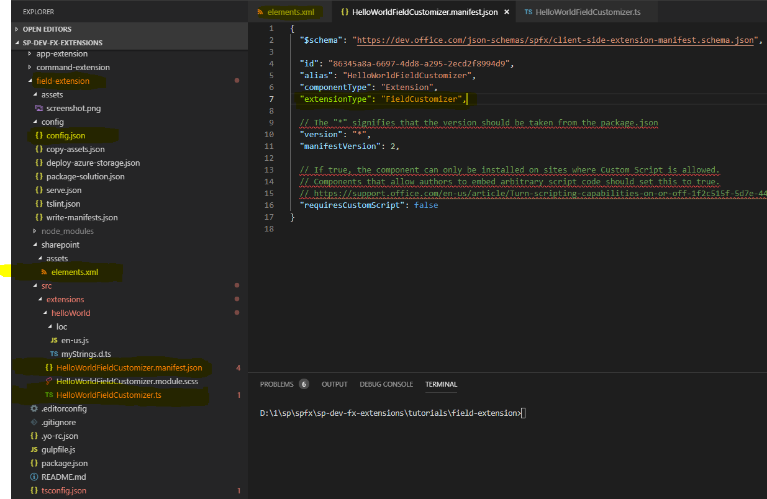 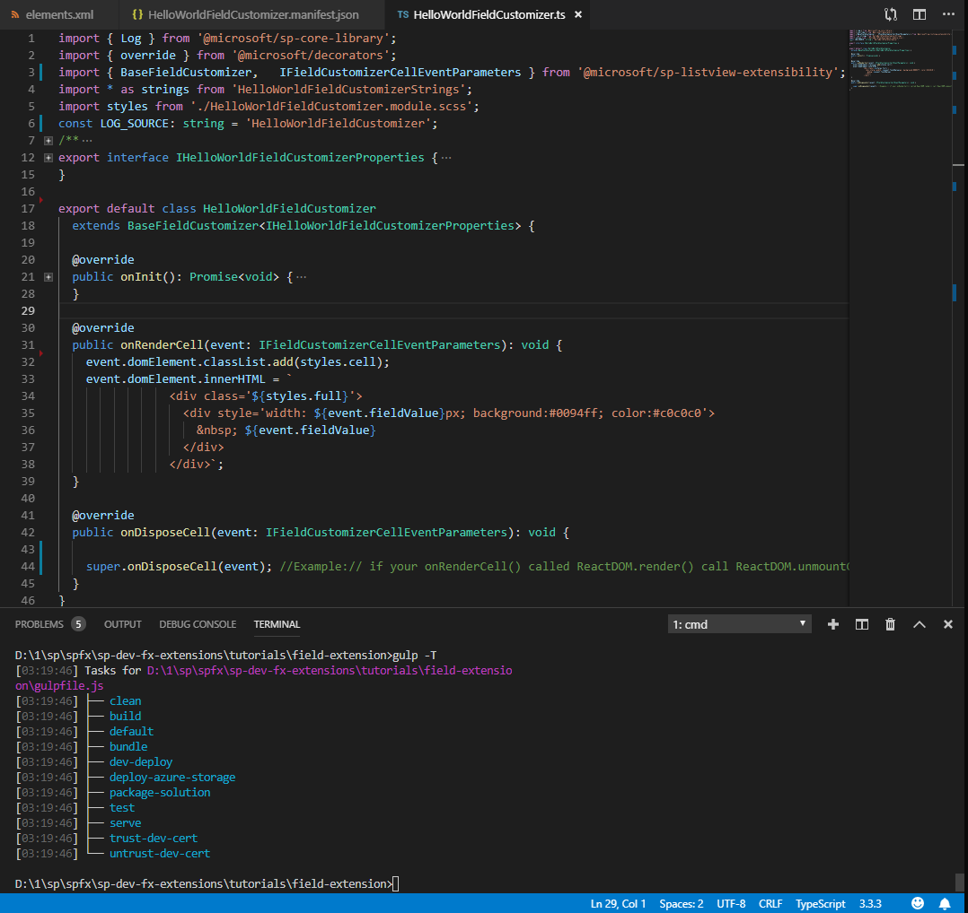

**Step1:** Ensure id:<guid> that is being used in the *customizer.manifest.json file is reflected in the serve.json and elements.xml files at appropriate places.. eg: elements.xml has attribute-param below,

ClientSideComponentId="ec6aff04-2b7a-4f9d-b041-14322f3b2f18"

**\*\*\*\*\*\*\*\*\*\*\*\*\*\*\*\*\*\*\*\*\*\*\*\*\*\*\*** and serve.json as the later section shown below*************************************

"serveConfigurations": {

"default": {

"pageUrl": "https://appflowitmarch2019.sharepoint.com/sites/Countries/Lists/T4Test/AllItems.aspx",

"fieldCustomizers": {

"SPFxPercentage2": {

"id": "ec6aff04-2b7a-4f9d-b041-14322f3b2f18",

"properties": {

"sampleText": "Hello"

}

}

}

}

}

**Step2: Build solution: gulp serve –nobrowser**  **;** **gulp bundle --ship**

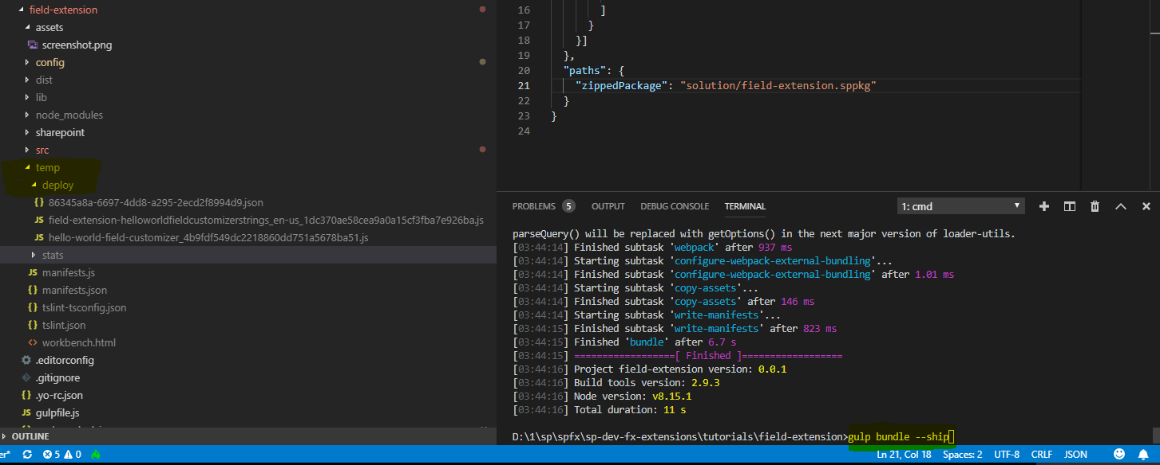

**Step3: Debug deploy: gulp trust-dev-cert**   **;**  **gulp serve --config default**   **;** install the self-signed-cert locally ; copy temp/deploy contents to CDN

|  |  |
| --- | --- |
|  |  |

**Step3: Package solution: gulp package-solution --ship**   **;** Upload **/sharepoint/*.sppkg** file to the AppCatalog (Tenant/SiteCollection)

Before packaging ensure ( **ClientSiteComponentId | ClientSideComponentProperties**): <https://docs.microsoft.com/en-us/sharepoint/dev/spfx/extensions/get-started/building-simple-field-customizer#add-the-field-definition-to-the-solution-package-for-deployment>

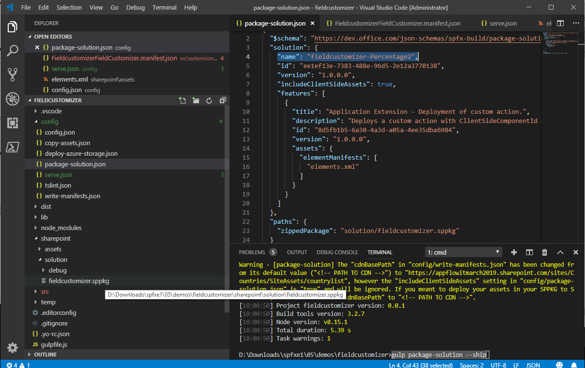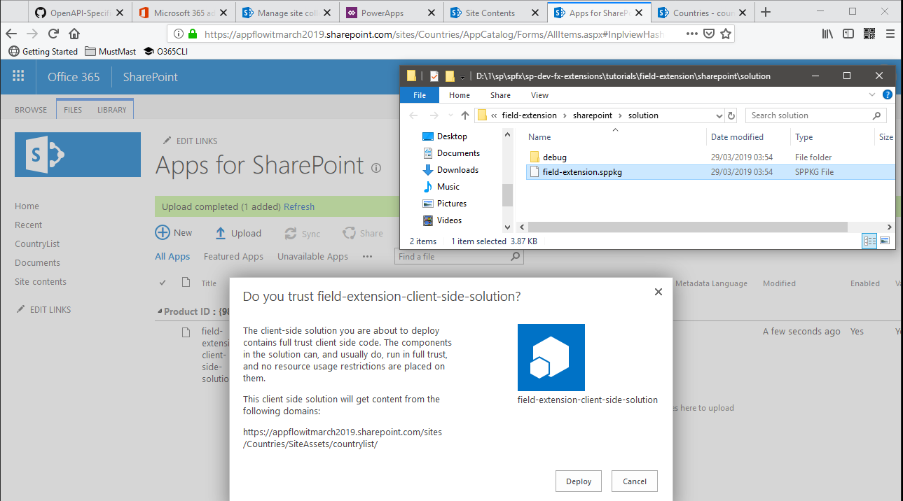

**Step4 : Consume : Ensure List with Site-Column (provisioned through this package) exists ;Navigate to “Site Contents” page and New->App and Add the app named in the package-solution.json to create an instance…**

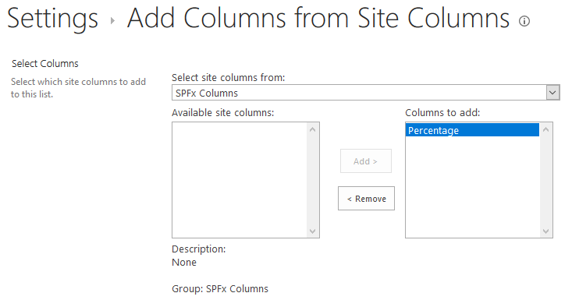 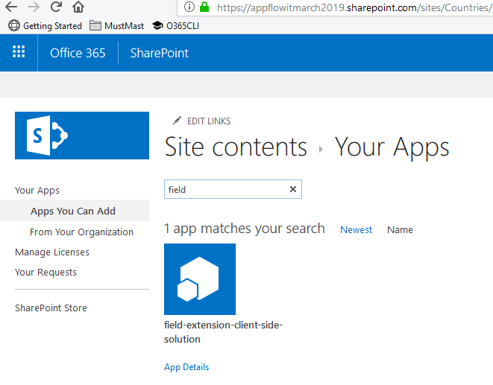

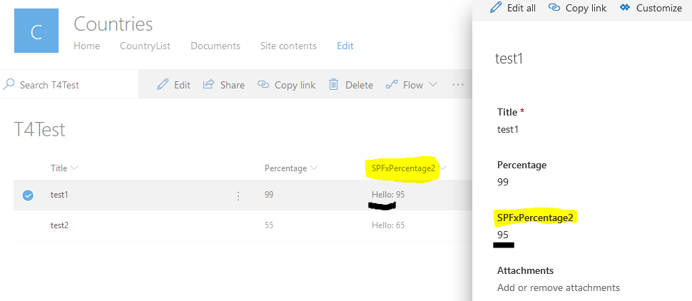

### Field Customizer

|  |  |
| --- | --- |
| Samples: SPFX Extensions | Field Customizer - Sahil Malik’s Pluralsight (SPFX Extensions course): <https://app.pluralsight.com/player?course=sharepoint-framework-extensions&author=sahil-malik&name=4b77fe11-5ab7-4161-9331-819099c4cbb7&clip=3&mode=live>  [**sp-dev-fx-extensions**](https://github.com/SharePoint/sp-dev-fx-extensions) @GitHub |
| MSDN Docs | **https://docs.microsoft.com/en-us/sharepoint/dev/spfx/extensions/get-started/building-simple-field-customizer#code-your-field-customizer** |

**For this scenario and spfx-field-extension implementation – needs something that can justify programming:** The Countries list has a field **RESTCountriesEUJSON** where data needs presentation against the stored JSON format.

Step1: Initialize project with template project-code:

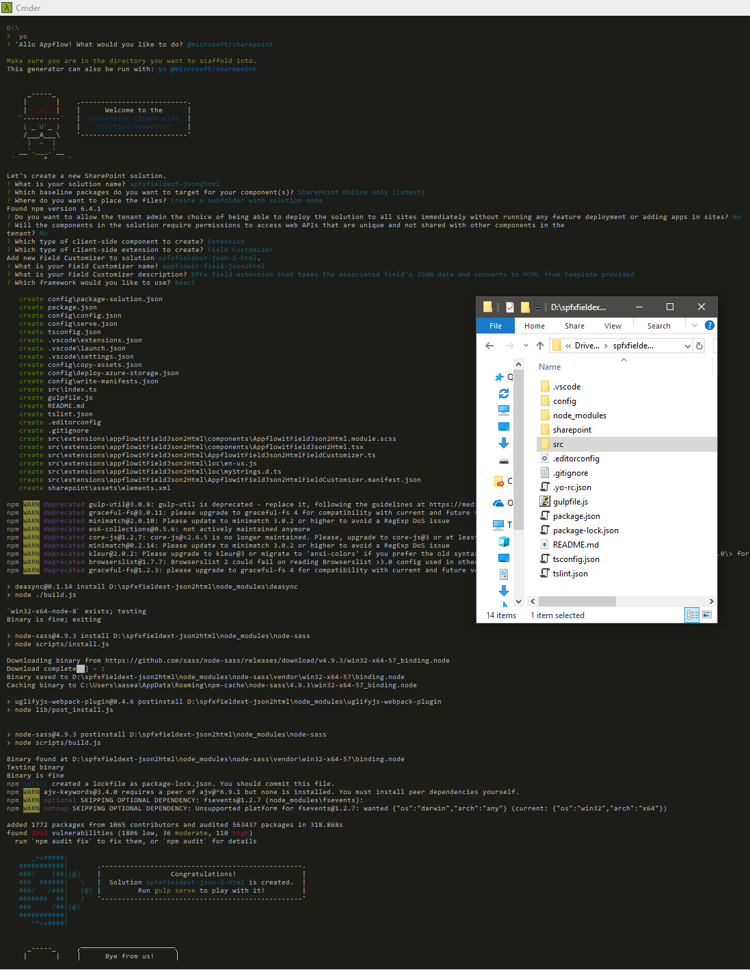

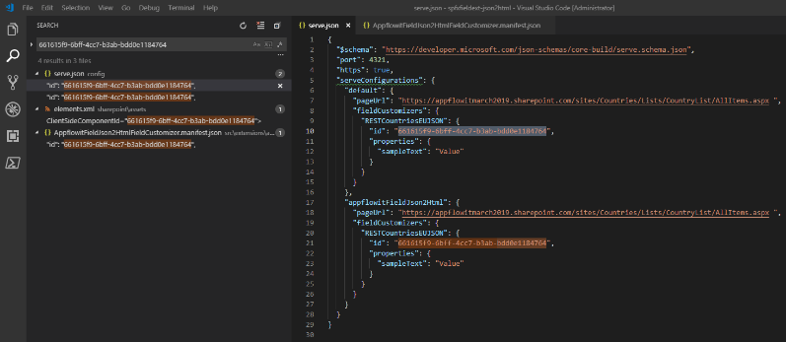Step2: Coding the bits:

Go to CountryList -> List settings -> and reach to the RESTCountriesEUJSON column and copy Url for further reference

[https://appflowitmarch2019.sharepoint.com/sites/Countries/_layouts/15/FldEdit.aspx? List**={8F69E8D4-1CC2-4329-993D-BC8556C6438F}**&Field=**RESTCountriesEUJSON**](https://appflowitmarch2019.sharepoint.com/sites/Countries/_layouts/15/FldEdit.aspx?%20List=%7b8F69E8D4-1CC2-4329-993D-BC8556C6438F%7d&Field=RESTCountriesEUJSON)

Lets check compile and debug execution ability: **gulp serve --config default ;;**

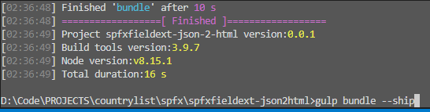 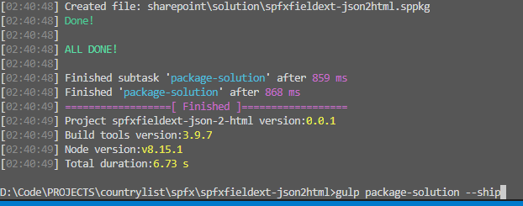

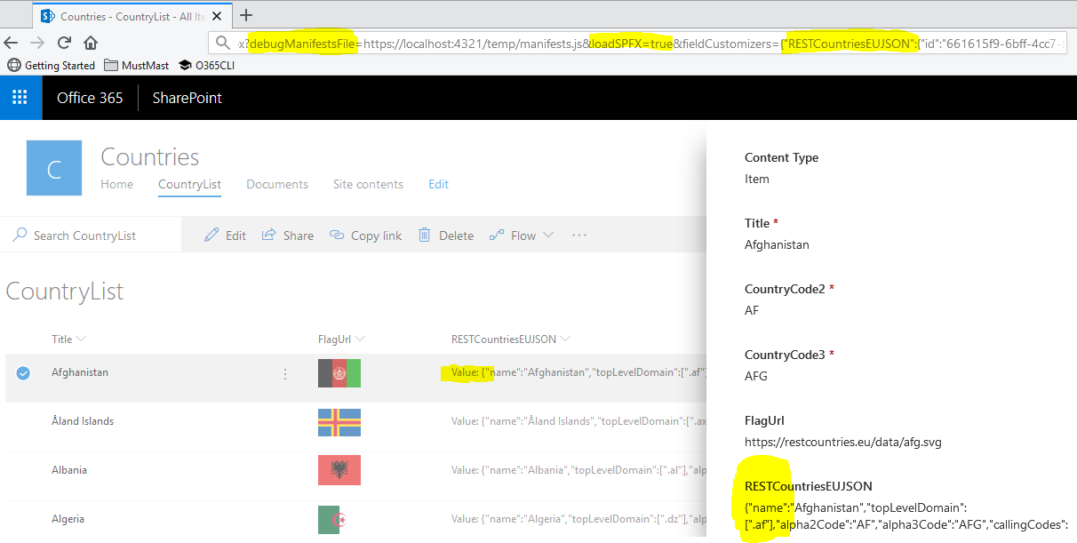

[https://appflowitmarch2019.sharepoint.com/sites/Countries/Lists/CountryList/AllItems.aspx?debugManifestsFile=https://localhost:4321/temp/manifests.js &loadSPFX=true &fieldCustomizers={"RESTCountriesEUJSON": {"id":"661615f9-6bff-4cc7-b3ab-bdd0e1184764","properties":{"sampleText":"Value"}}}](https://appflowitmarch2019.sharepoint.com/sites/Countries/Lists/CountryList/AllItems.aspx?debugManifestsFile=https://localhost:4321/temp/manifests.js%20&loadSPFX=true%20&fieldCustomizers=%7b%22RESTCountriesEUJSON%22:%20%7b%22id%22:%22661615f9-6bff-4cc7-b3ab-bdd0e1184764%22,%22properties%22:%7b%22sampleText%22:%22Value%22%7d%7d%7d)

How-To: [**JSON2HTML Transform Library (React)**:](https://www.npmjs.com/package/react-json-to-html) **npm install react-json-to-html –save**

*src\extensions\appflowitFieldJson2Html\AppflowitFieldJson2HtmlFieldCustomizer.ts*

import {JsonTable} from 'react-json-to-html';

export default class AppflowitFieldJson2HtmlFieldCustomizer

extends BaseFieldCustomizer<IAppflowitFieldJson2HtmlFieldCustomizerProperties> {

@override

public onRenderCell(**event**: IFieldCustomizerCellEventParameters): void {

let currentFieldValue :string = event.fieldValue;

const appflowitFieldJson2Html: React.ReactElement<{}> =

React.createElement(AppflowitFieldJson2Html, { currentFieldValue } as IAppflowitFieldJson2HtmlProps);

ReactDOM.render(appflowitFieldJson2Html, **event**.domElement);

}

Adding some css in the scss file : src\extensions\appflowitFieldJson2Html\components\AppflowitFieldJson2Html.module.scss

.DivJsonTable{

height:250px;

max-height:250px;

overflow-y:scroll;

}

Finally, the important bit of code looks like this,

export default class AppflowitFieldJson2Html extends React.Component<IAppflowitFieldJson2HtmlProps, {}> {

@override

public render(): React.ReactElement<{}> {

return (

<ScrollArea speed={0.8} className="area" contentClassName="content" horizontal={false}>

<div className={styles.DivJsonTable}> <JsonTable json={this.props.currentFieldValue} /> </div>

</ScrollArea>

); }

Ensure tasks: <https://docs.microsoft.com/en-us/powershell/module/sharepoint-pnp/set-pnpfield?view=sharepoint-ps>

Step3 Deployment (covered extensively at start – bundle ; “gulp package-solution --ship”) and Showcase:

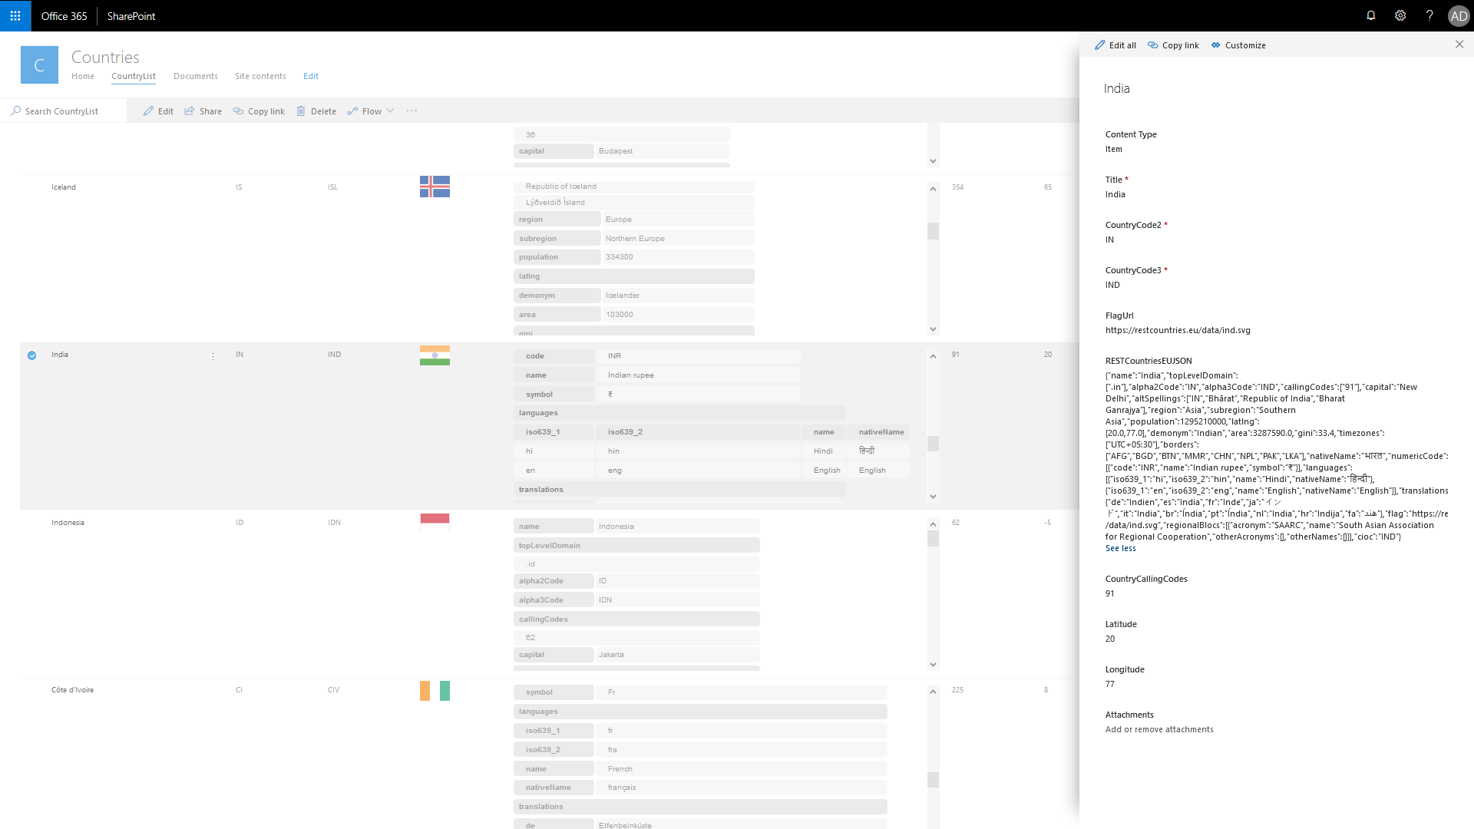

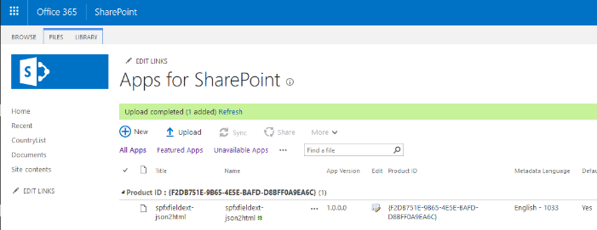 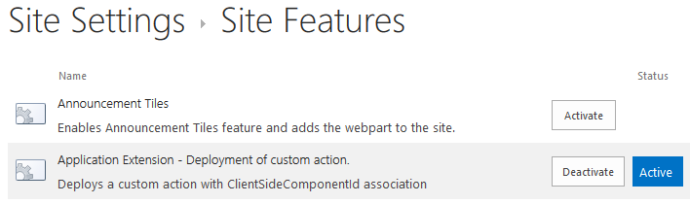

Before: 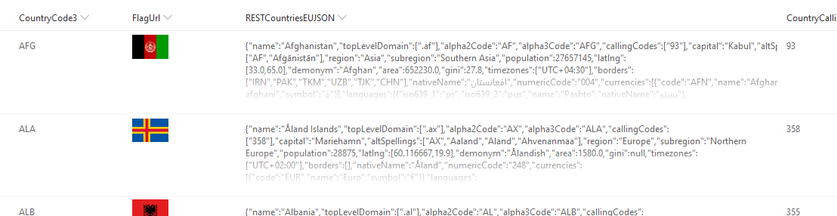 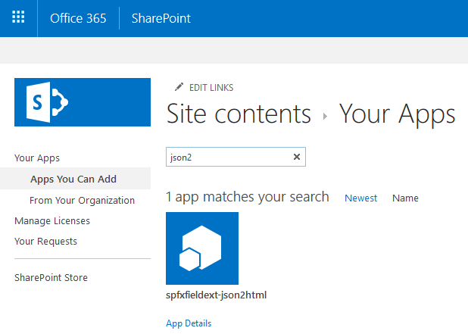

After: Ensuring to associate this spfx-field-extension with the EXISTING-LIST-COLUMN with [ClientSiteComponentId](https://docs.microsoft.com/en-us/powershell/module/sharepoint-pnp/set-pnpfield?view=sharepoint-ps)

$siteUrl = "https://appflowitmarch2019.sharepoint.com/sites/Countries"

$cred = Get-Credential -UserName "am@appflowitmarch2019.onmicrosoft.com" -Message "Enter password ..."

Connect-PnPOnline -Url $siteUrl -Credentials $cred

###https://docs.microsoft.com/en-us/powershell/module/sharepoint-pnp/set-pnpfield?view=sharepoint-ps

**Set-PnPField** -**List** "CountryList" -**Identity** "RESTCountriesEUJSON" -Values @{**ClientSideComponentId**=[GUID]("661615f9-6bff-4cc7-b3ab-bdd0e1184764")}

Read-Host -Prompt "Press Enter to exit ... "

Disconnect-PnPOnline



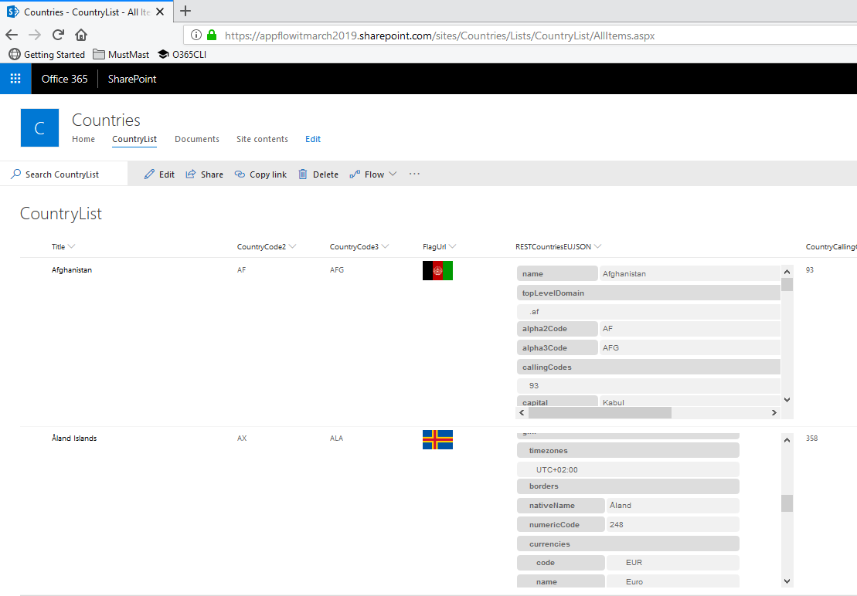

# HOPE THIS HELPED!?

Kindly feedback your thoughts and suggestions and ideas, that would be magical to get them😊

Cheers, Aaseaf Mahkahti | [sharepointjob@outlook.com](mailto:sharepointjob@outlook.com)

# DISCLAIMER

This document is provided “as-is”. Information and views expressed in this document, including URL and other Internet Web site references, may change without notice. You bear the risk of using it.

Some examples depicted herein are provided for illustration only and are fictitious.  No real association or connection is intended or should be inferred.

This document does not provide you with any legal rights to any intellectual property in any Appflow IT Solutions Ltd. products. You may copy and use this document for your internal, reference purposes.

© 2018 Appflow IT Solutions Ltd. All rights reserved.